**Assignment 5**

**====================================================================**

**Name:** Ahmed Nour

**Email: ahmedmohamednoour@gmail.com**

**====================================================================**

**Table of Contents**

**1) Q1** 4

**1. RTL code** 4

**2.** **Testbench code** 5

**3.** **Do file** 6

**4.** **QuestaSim Snippets** 7

**5.** **Constraint File** 7

**6.** **Elaboration** 8

**7.** **Synthesis** 9

1. Netlist 11

**8.** **Implementation** 12

**Comment** 14

**9. Linting** 15

**2) Q2** 16

**1. RTL code** 16

**2.** **Testbench code** 18

**3.** **Do file** 19

**5.** **Constraint File** 20

**6.** **Elaboration** 20

**7.** **Synthesis** 21

Netlist 22

**8.** **Implementation** 23

**9.** **Bitstream** 24

**10. Linting** 25

**3) Q3** 26

**1. RTL code** 26

**2.** **Testbench code** 27

**3.** **Do file** 28

**5.** **Constraint File** 29

**6.** **Elaboration** 29

**7.** **Synthesis** 30

1. Netlist 31

**8.** **Implementation** 32

**Comment** 33

**10. Bitstream** 34

**9. Linting** 34

**4) Q4** 35

**1. RTL code** 35

**2.** **Testbench code** 36

**3.** **Do file** 37

**5.** **Constraint File** 38

**6.** **Elaboration** 39

**7.** **Synthesis** 40

8. Netlist 41

**9. Linting** 42

**5) Q5** 43

**1. RTL code** 43

**2.** **Testbench code** 44

**3.** **Do file** 44

**5.** **Constraint File** 46

**6.** **Elaboration** 46

**7.** **Synthesis** 47

8.Netlist 49

**9. Linting** 50

# **1) Q1**

**1. RTL code**

1. TOP_Module

# **2.** **Testbench code**

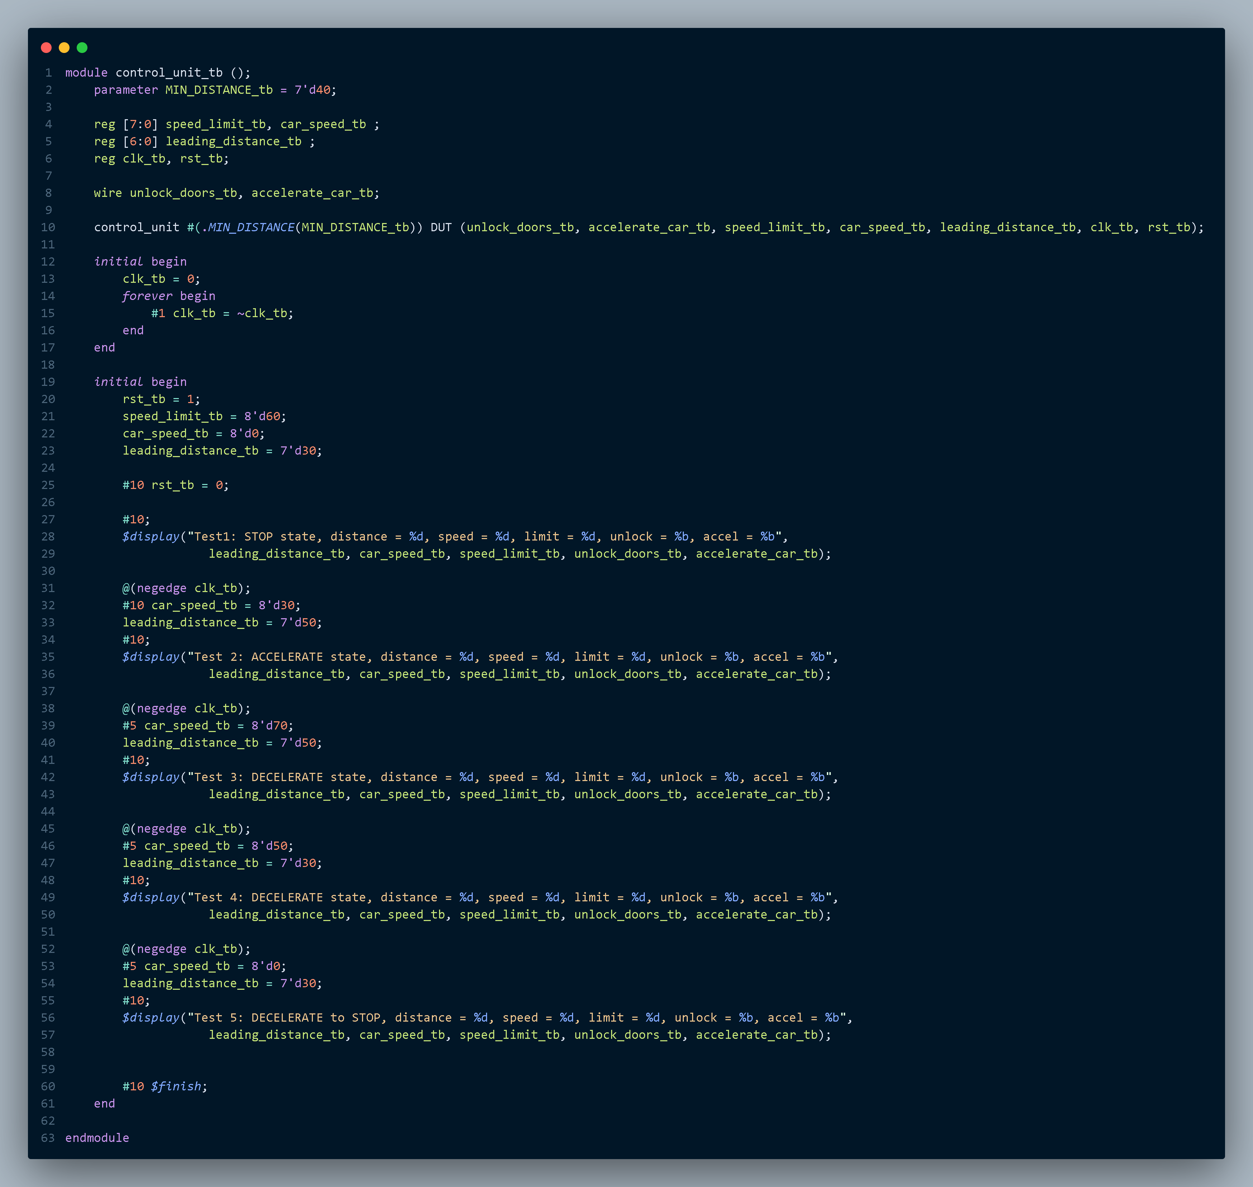

# **3.** **Do file**

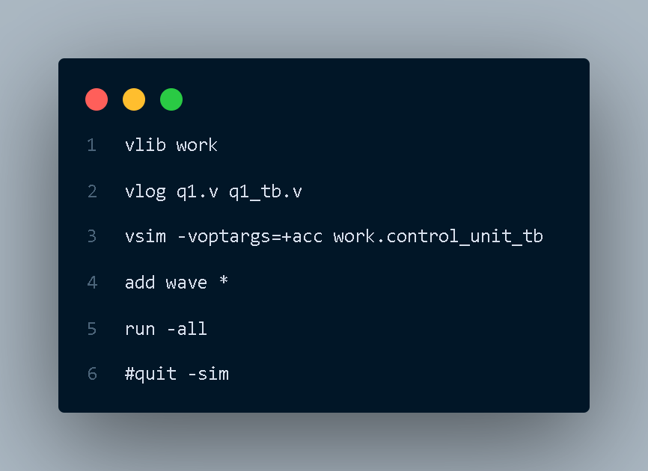

# **4.** **QuestaSim Snippets**

Messages Snippet

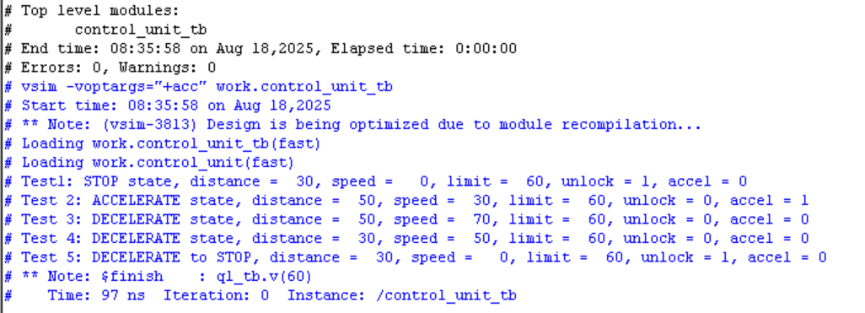

Waveform Snippet

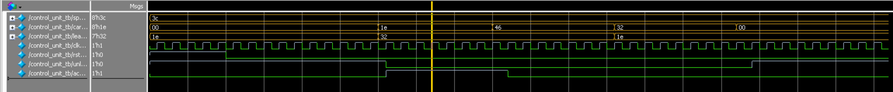

# **5.** **Constraint File**

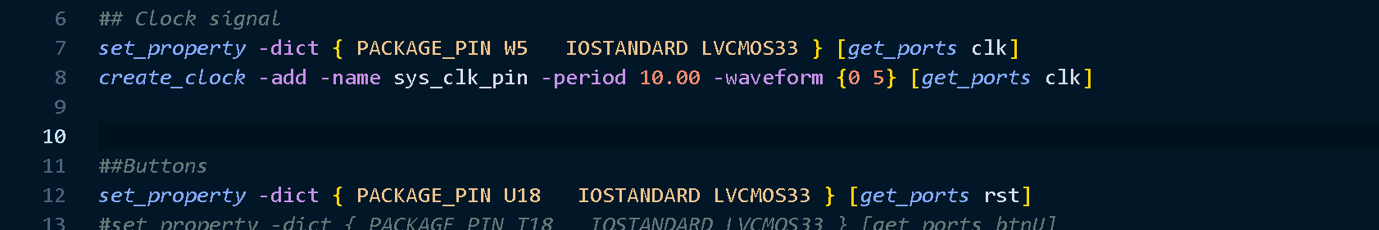

# **6.** **Elaboration**

Message tab

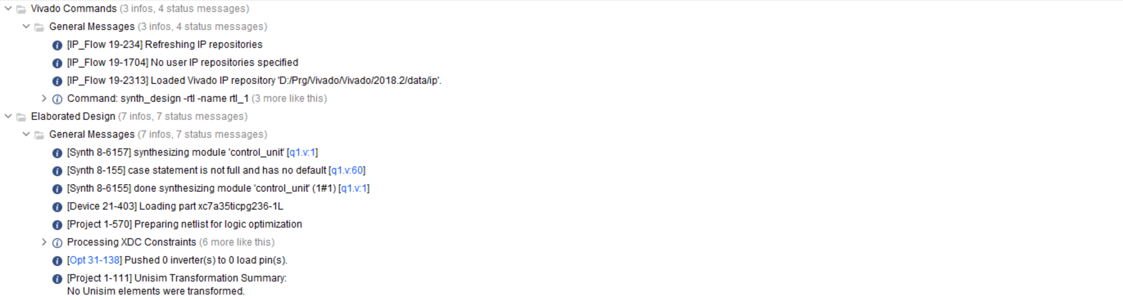

Schematic

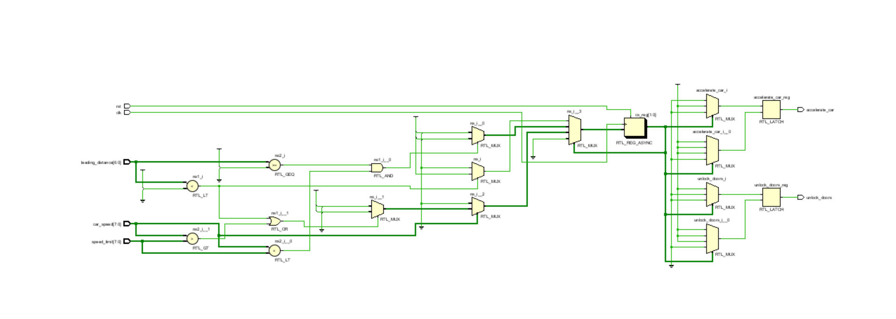

# **7.** **Synthesis**

Message Tab

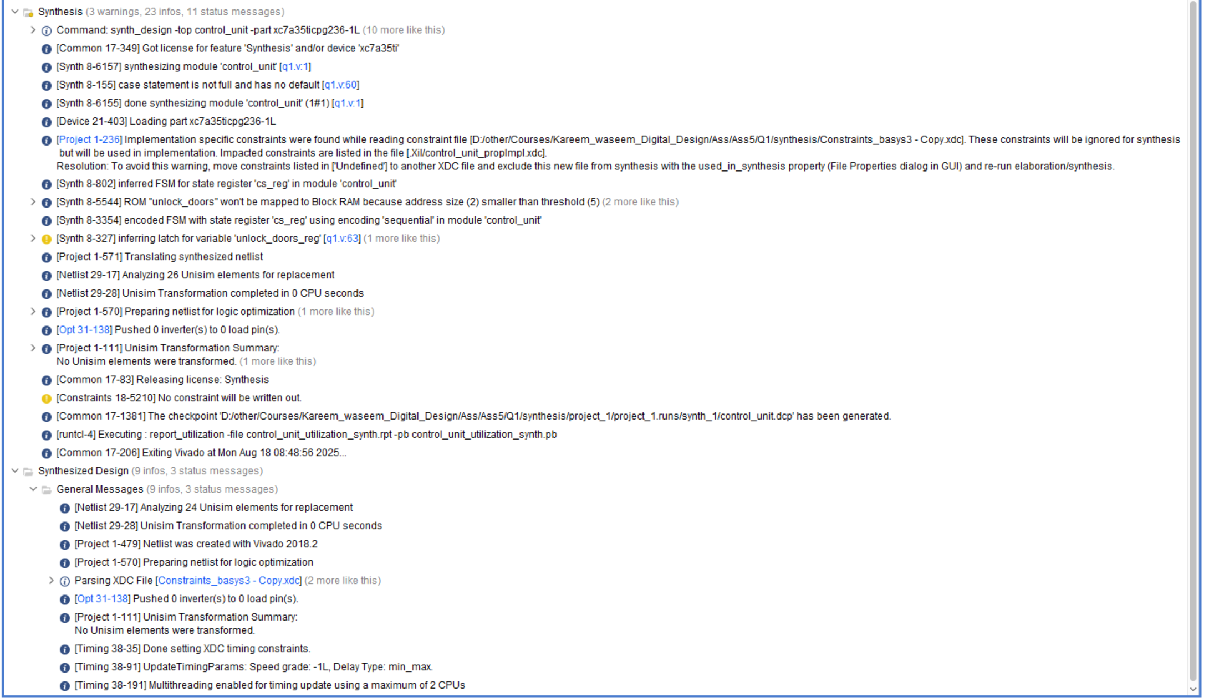

Utilization report

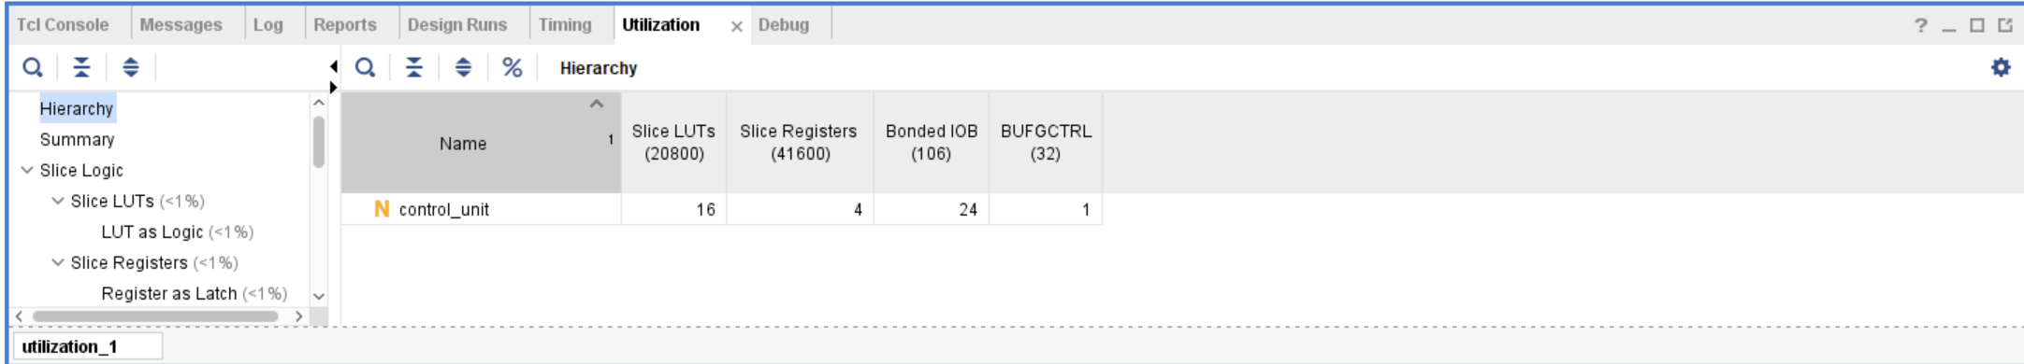

Timing report

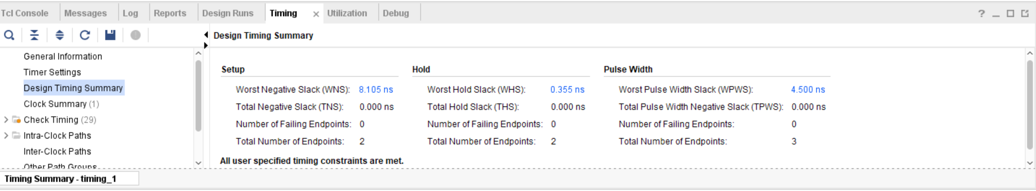

Schematic

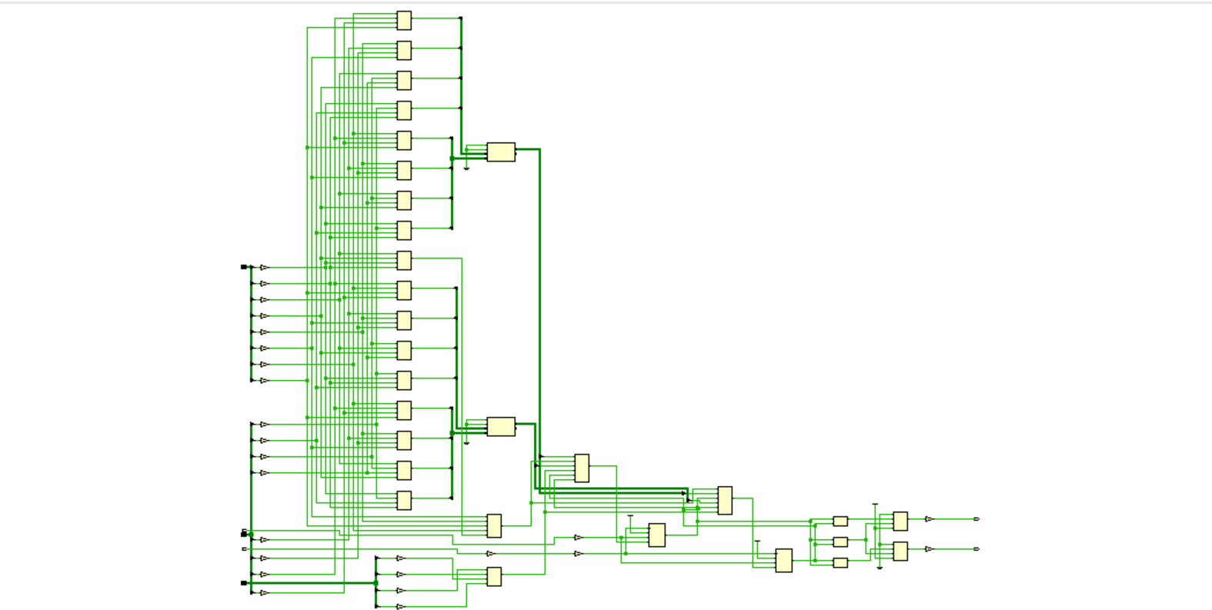

## Netlist

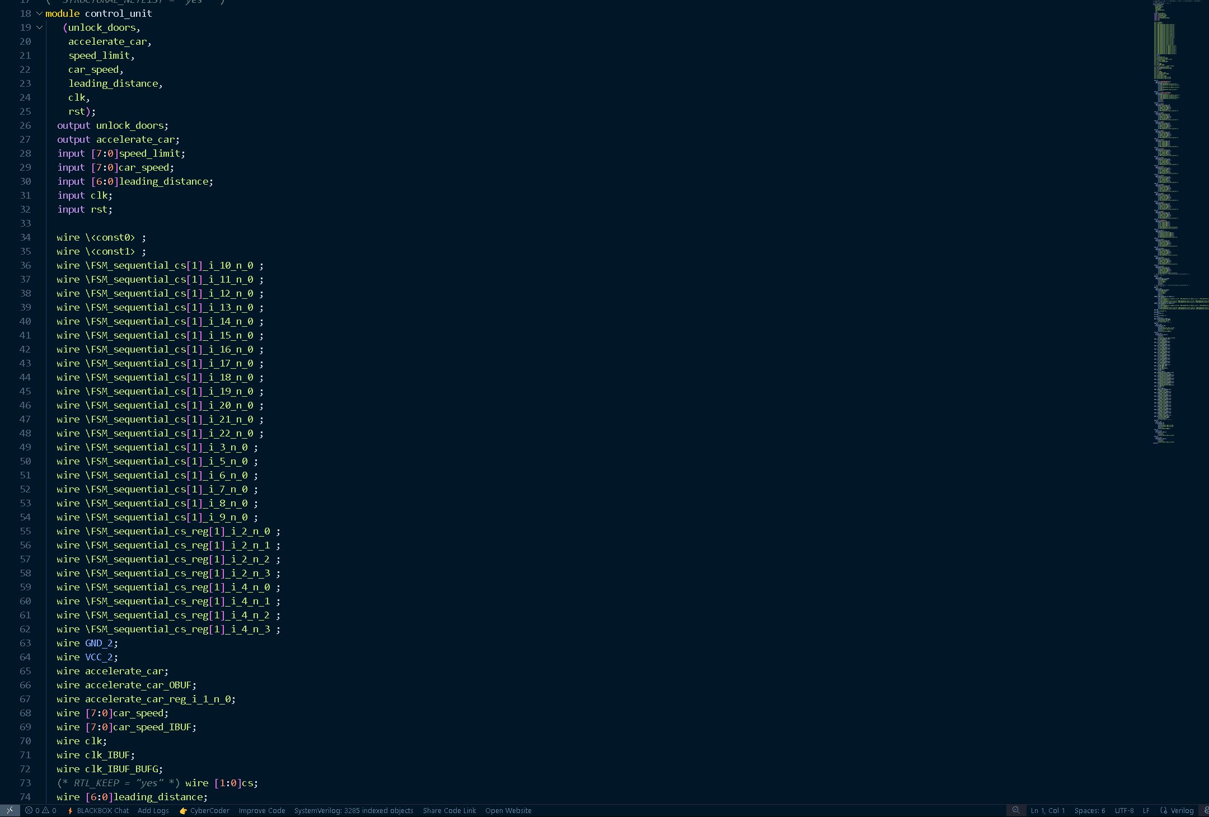

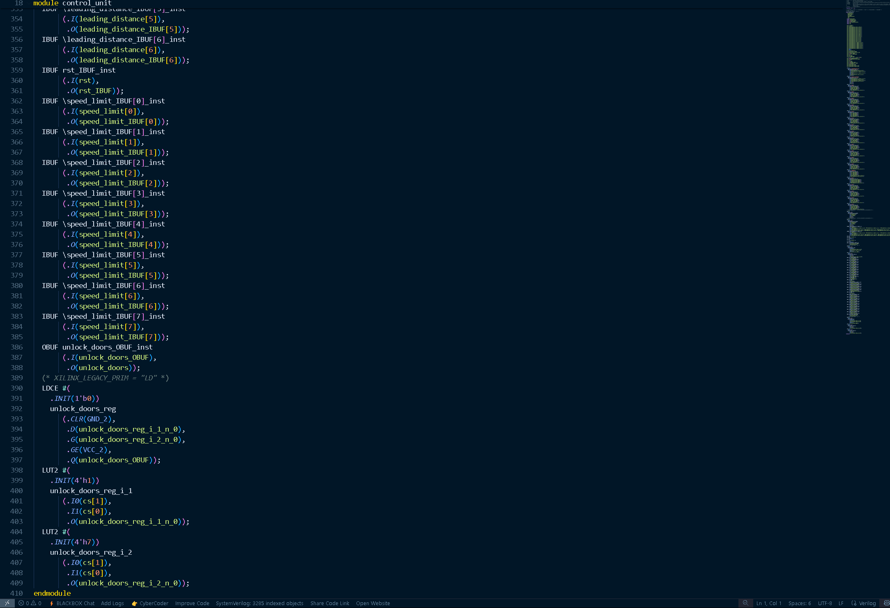

# **8.** **Implementation**

Message Tab

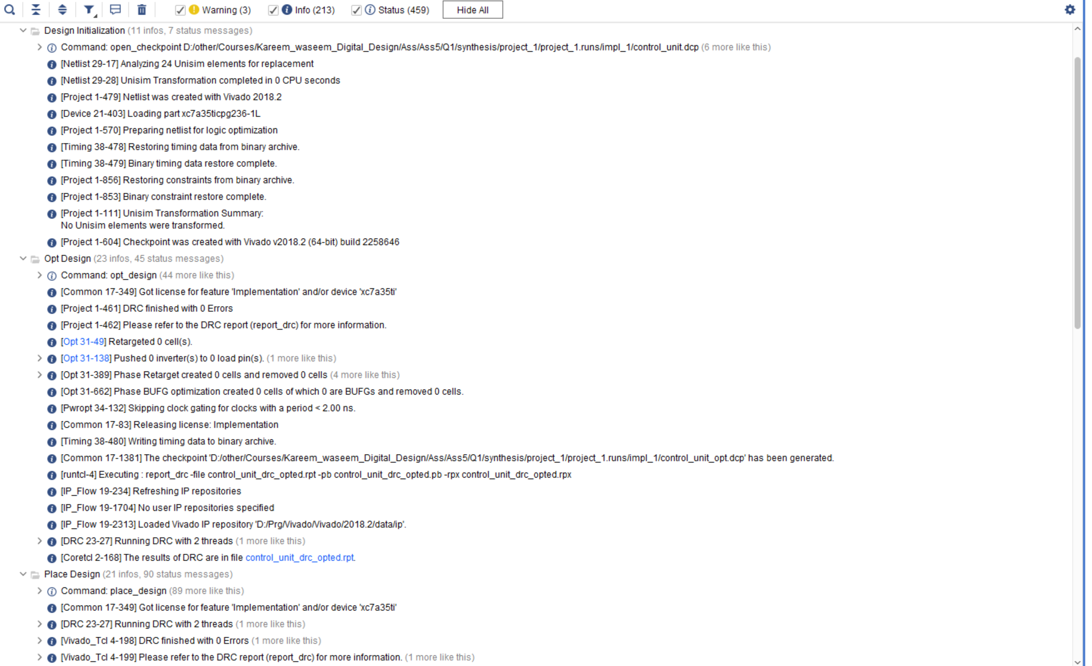

Utilization report

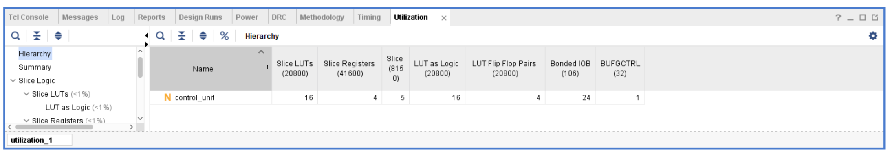

Timing report

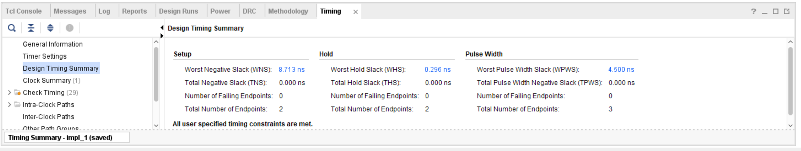

Device

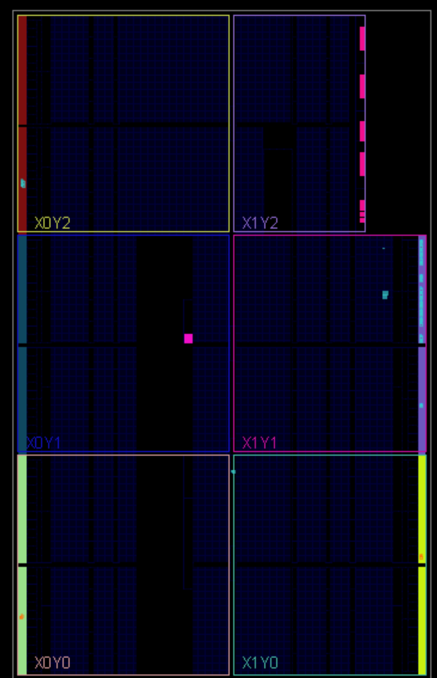

# **Comment**

One hot encoding:

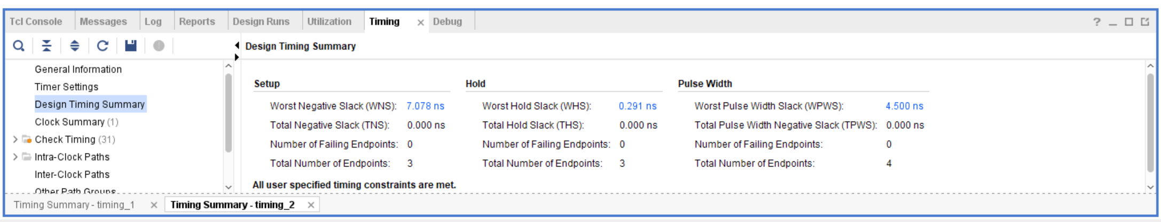

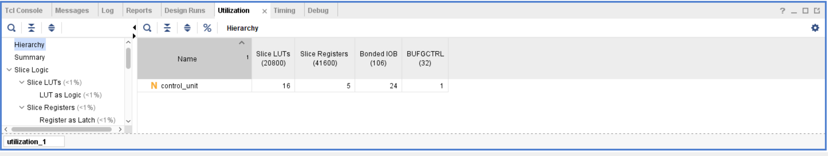

Gray encoding:

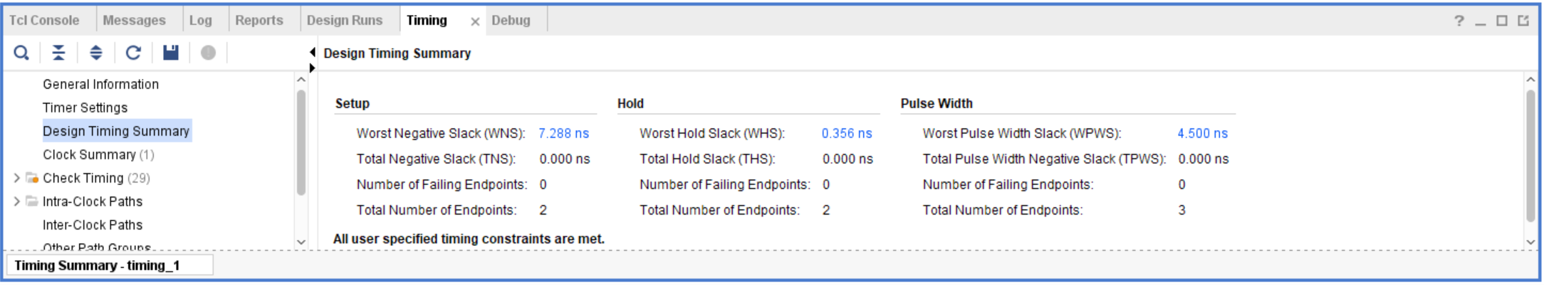

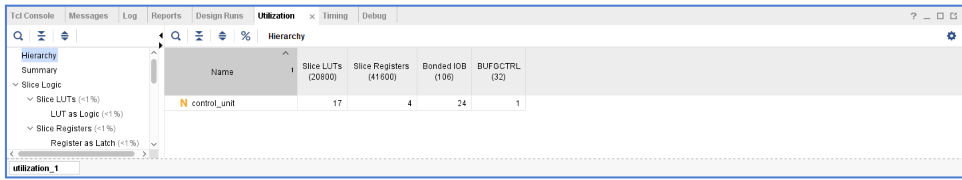

It appears that best encoding in general for the design is one hot encoding

# **9. Linting**

Lint snippet

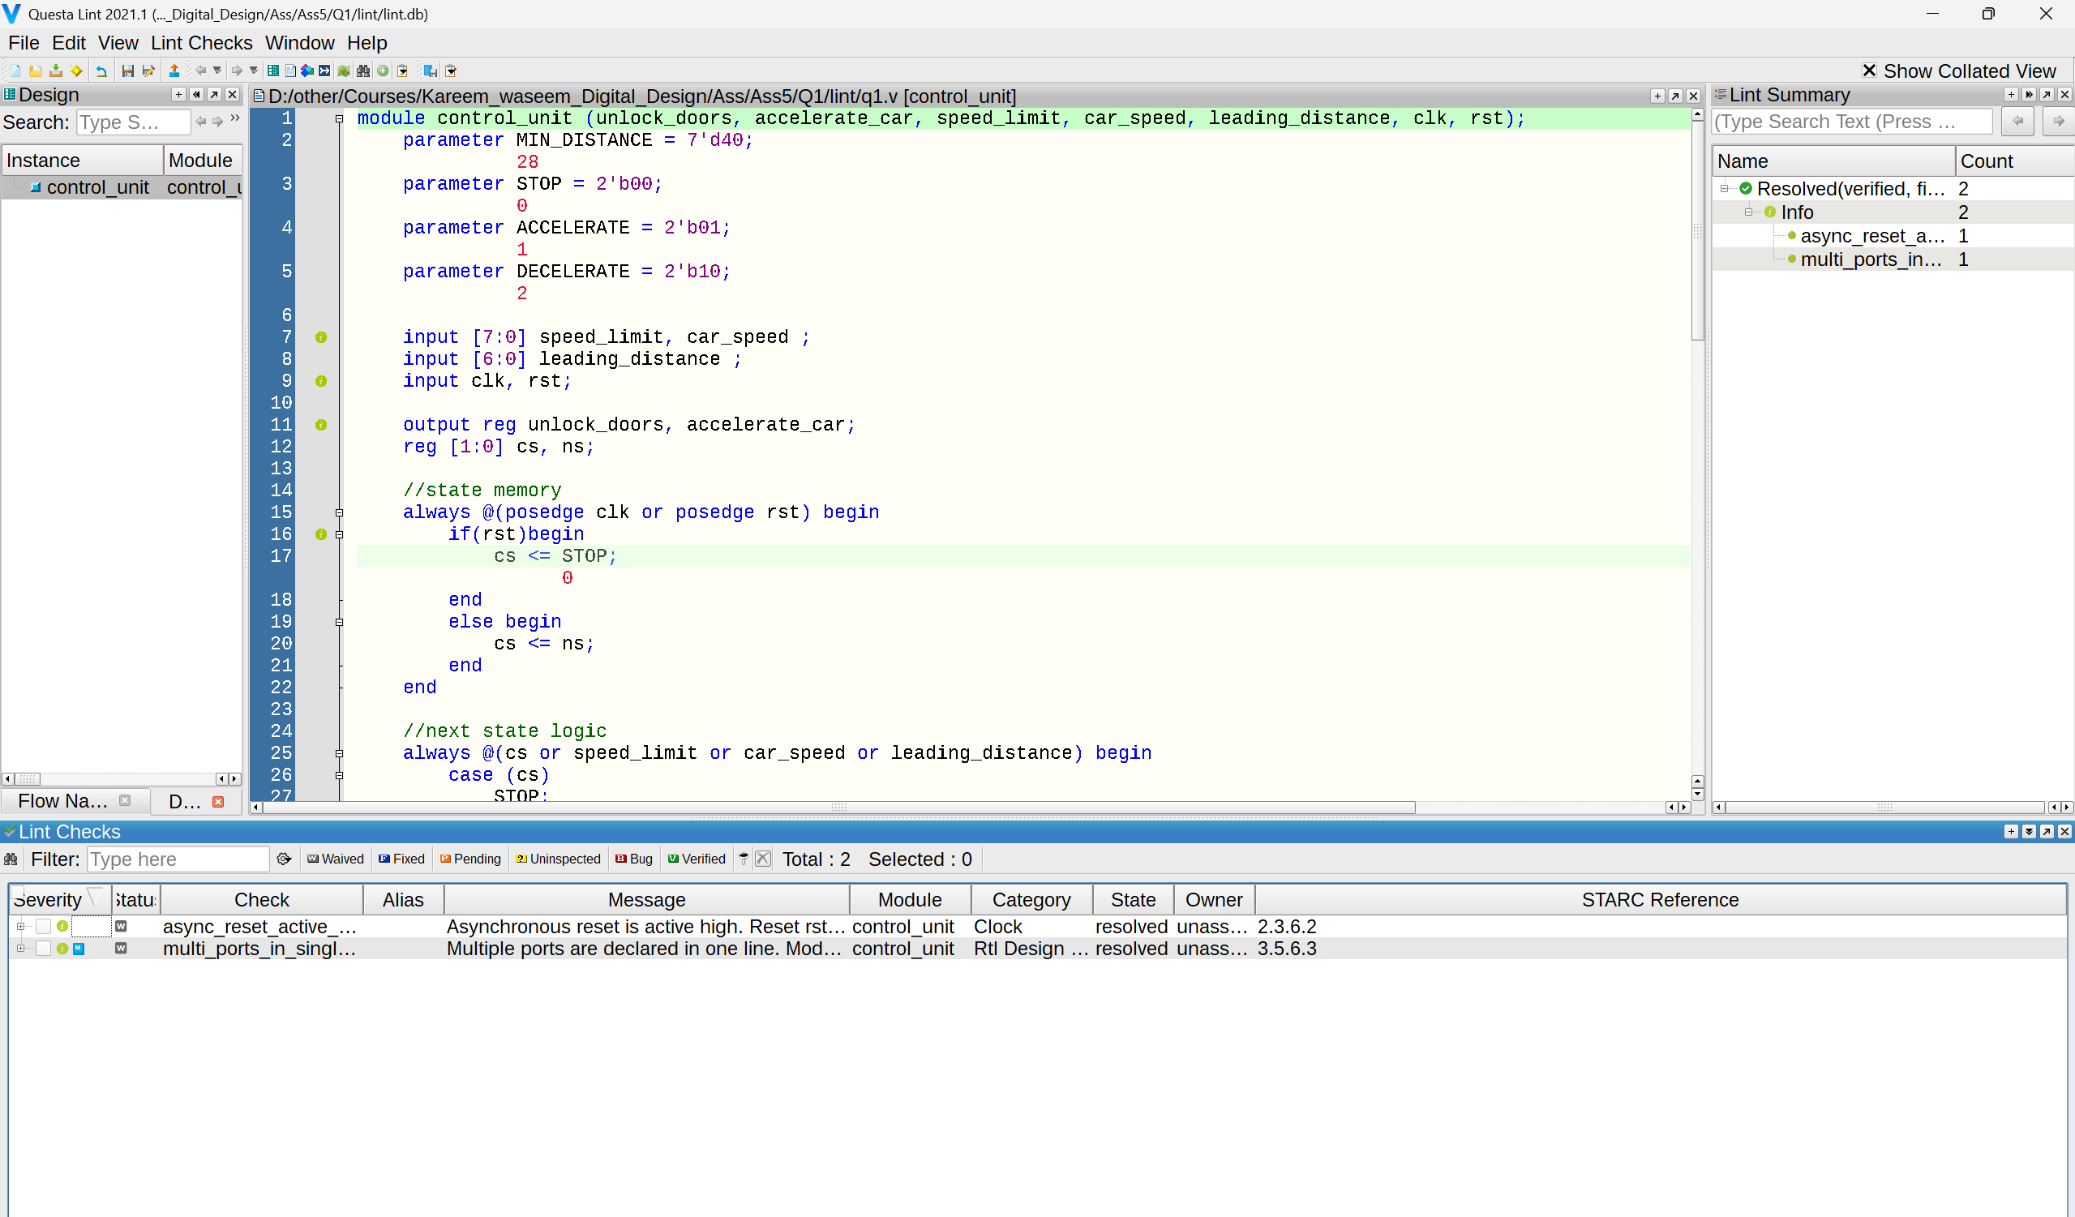

Lint Schematic

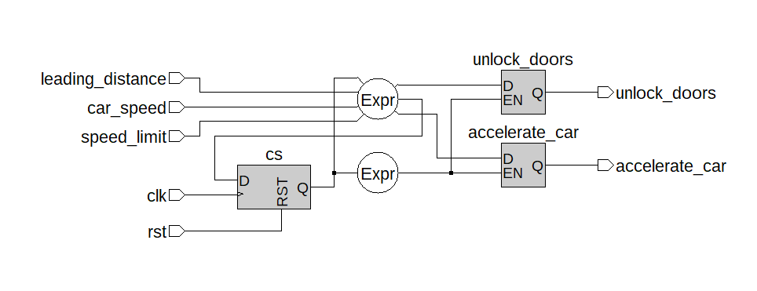

# **2) Q2**

# **1. RTL code**

1. TOP_Module

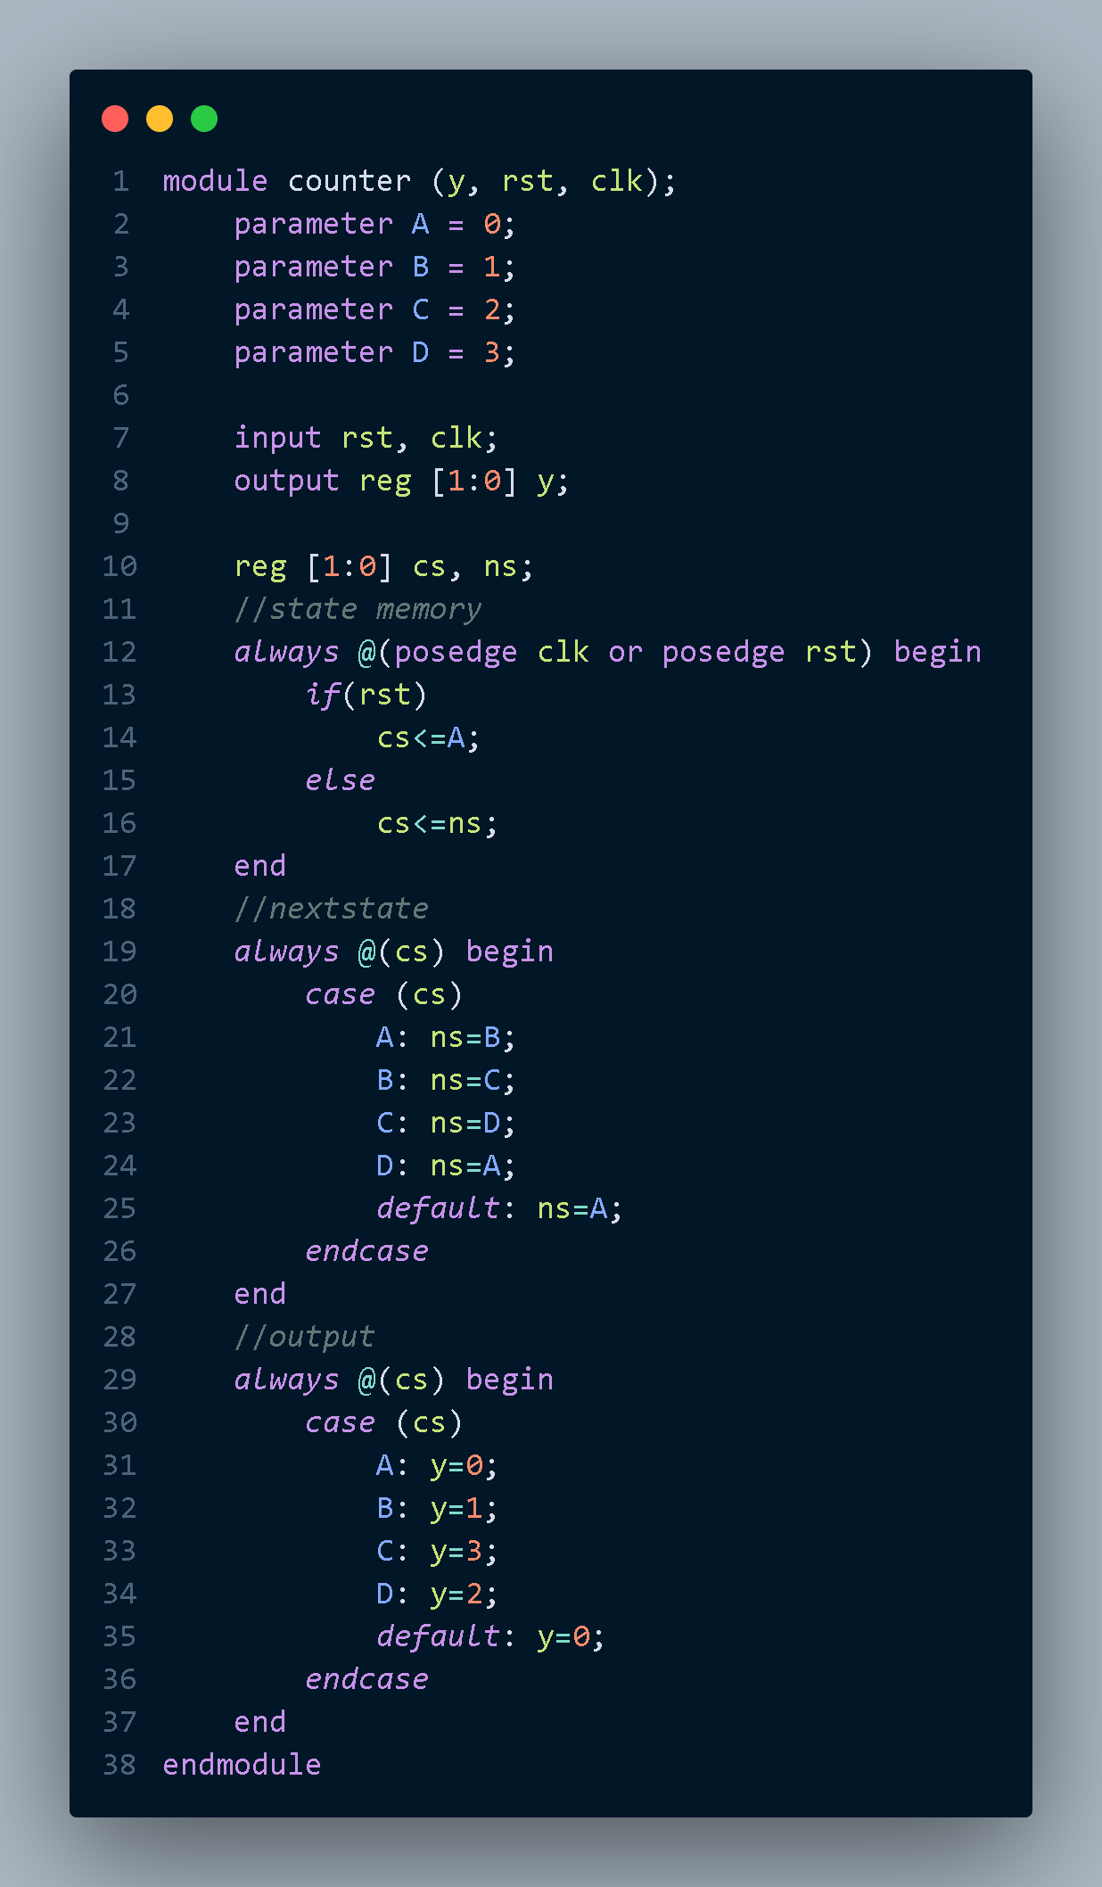

2) Reference module

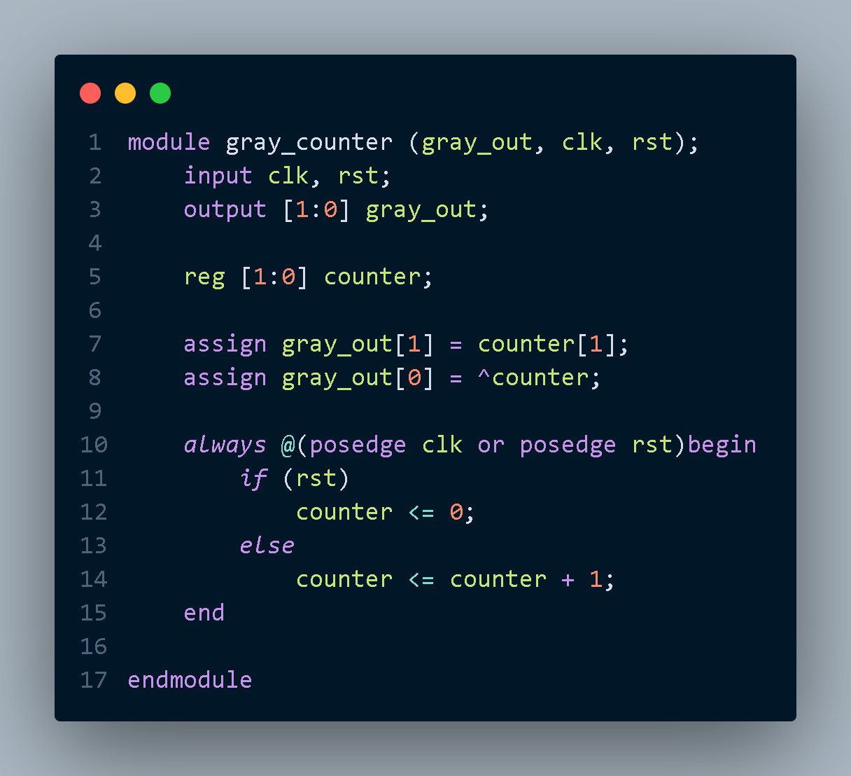

# **2.** **Testbench code**

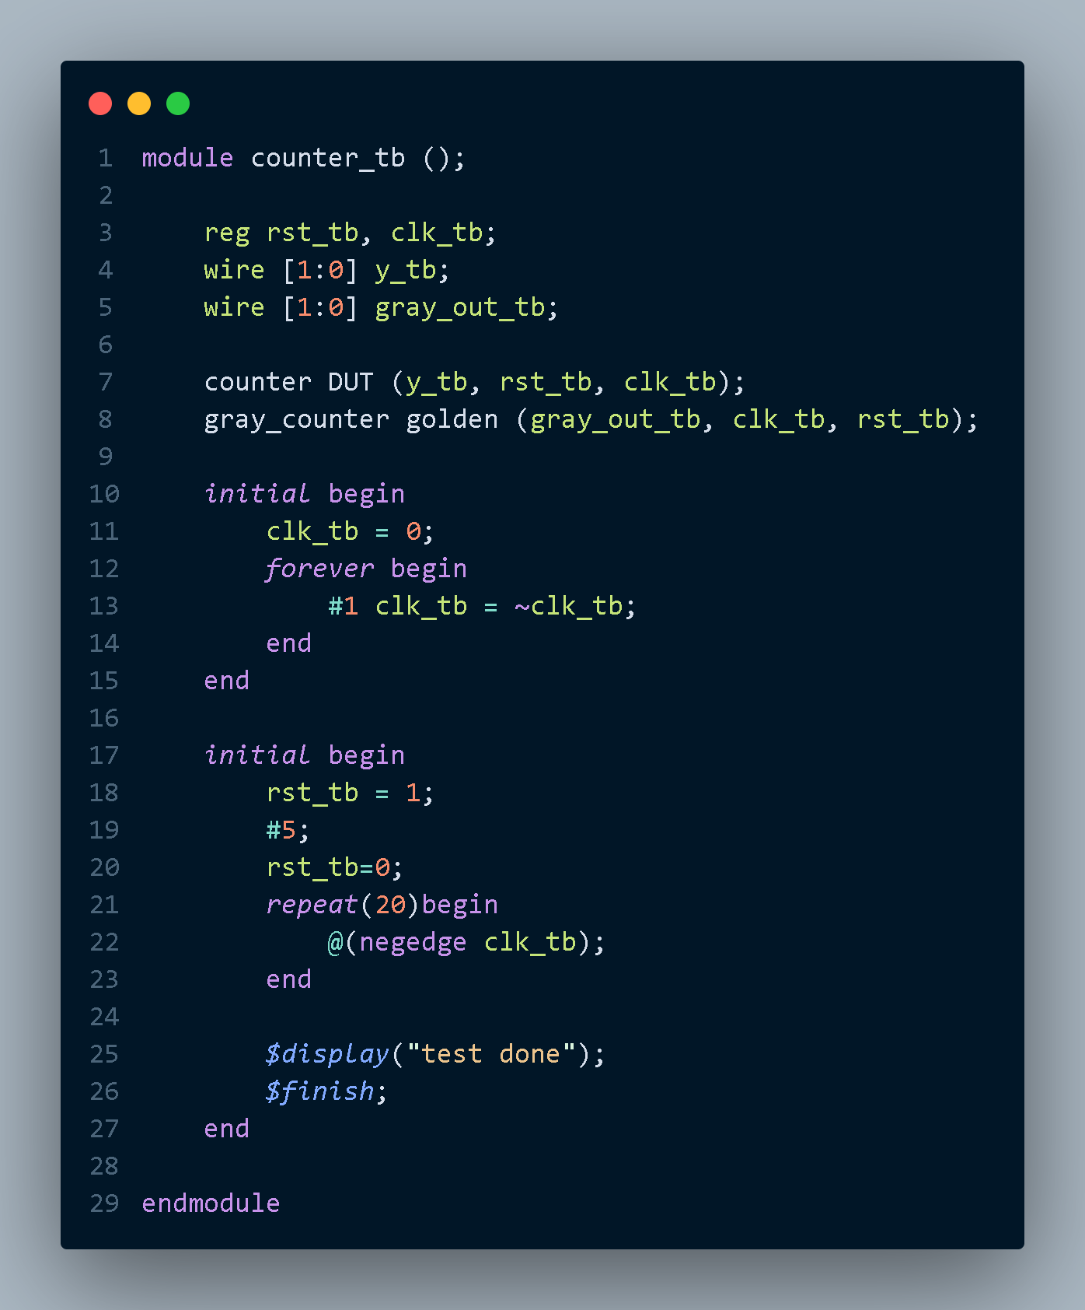

# **3.** **Do file**

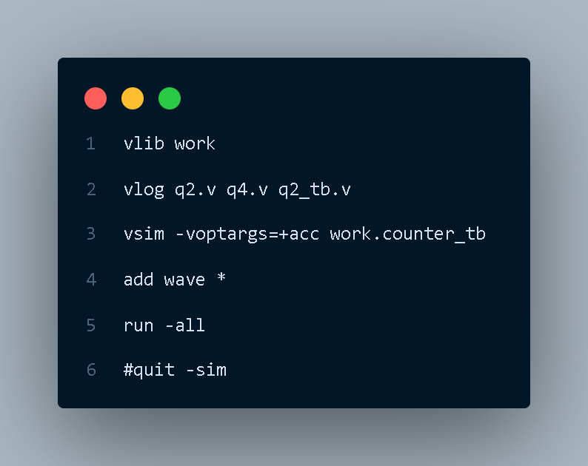

**4.** **QuestaSim Snippets**

Messages Snippet

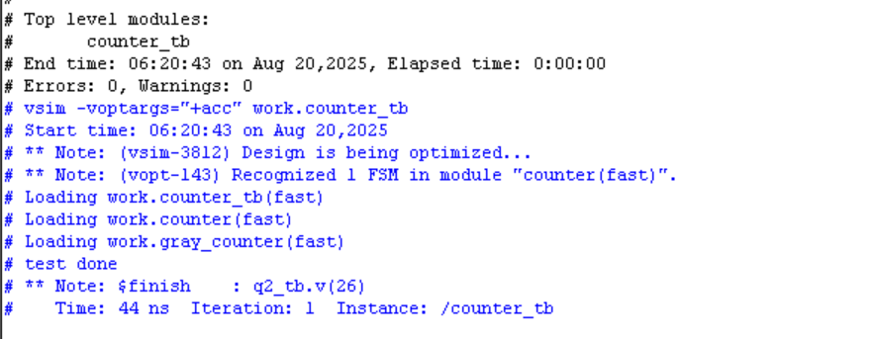

Waveform Snippet



# **5.** **Constraint File**

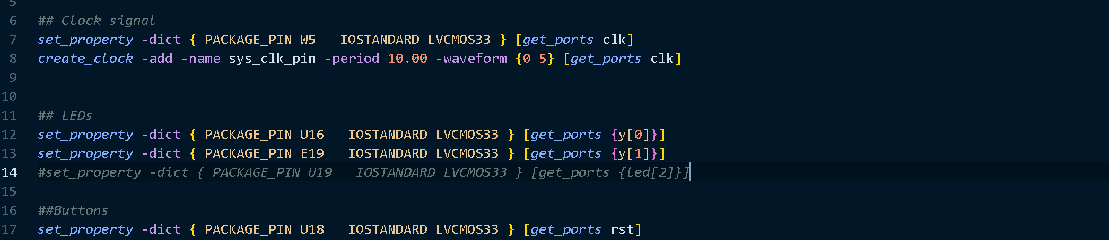

# **6.** **Elaboration**

Message tab

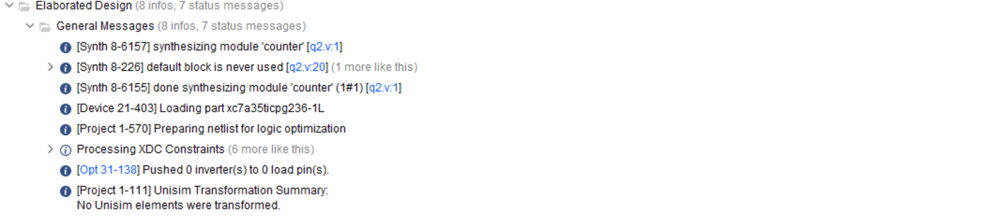

Schematic

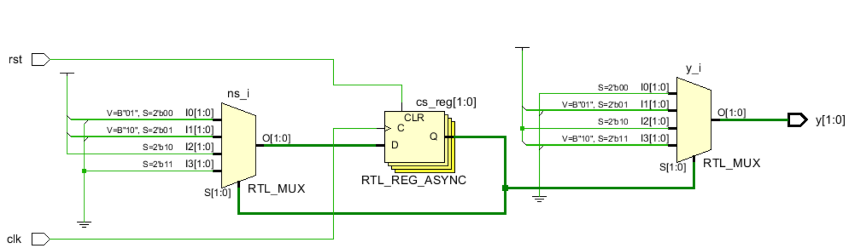

# **7.** **Synthesis**

Message Tab

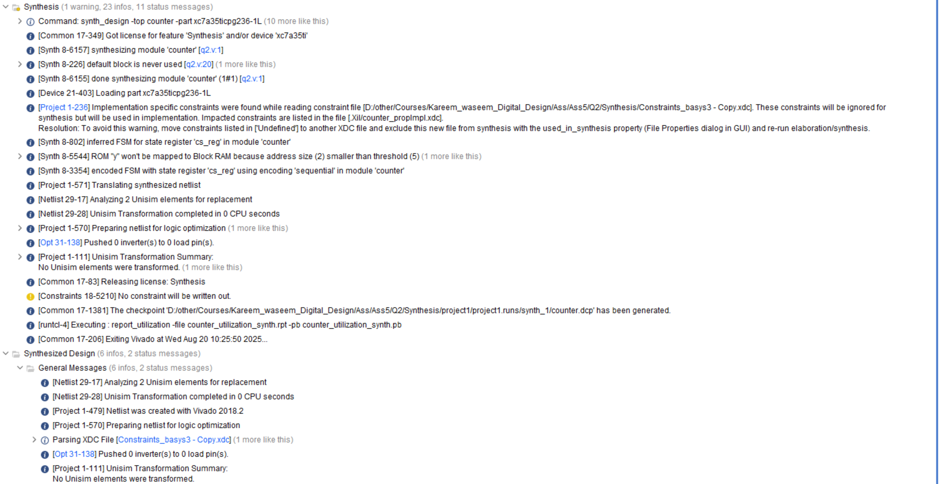

Utilization report

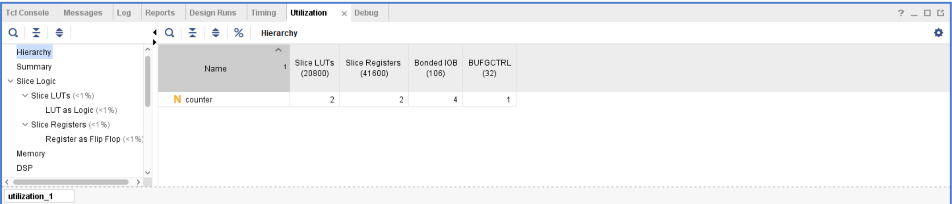

Timing report

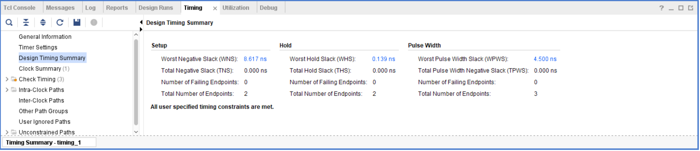

Schematic

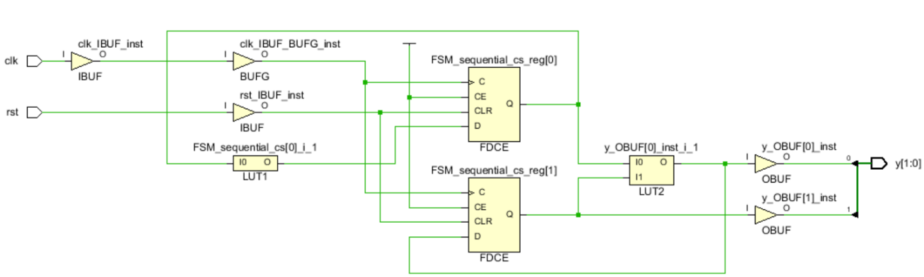

## Netlist

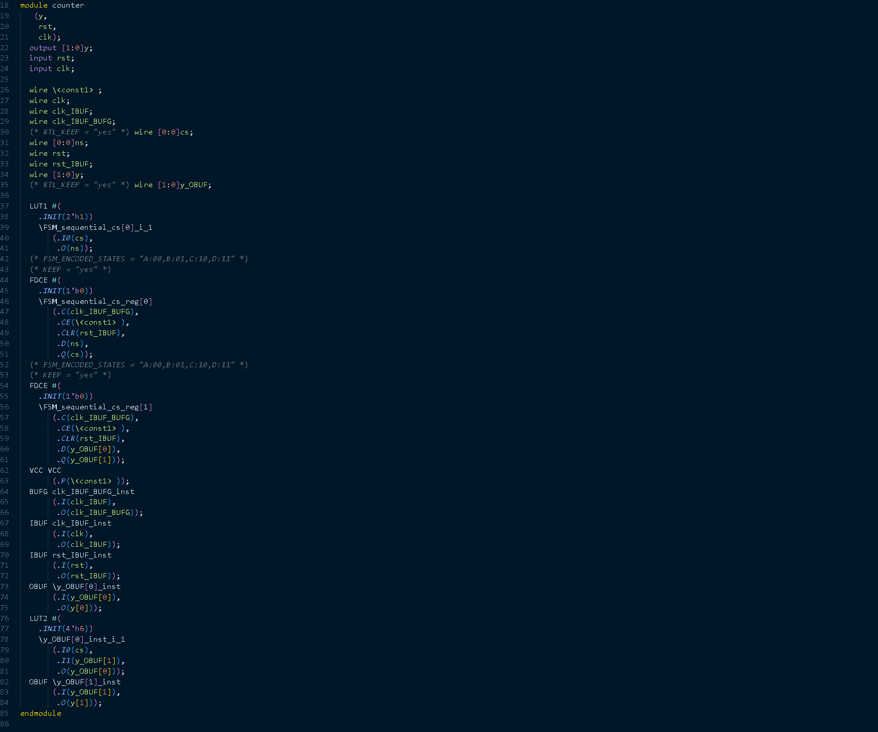

# **8.** **Implementation**

Message Tab

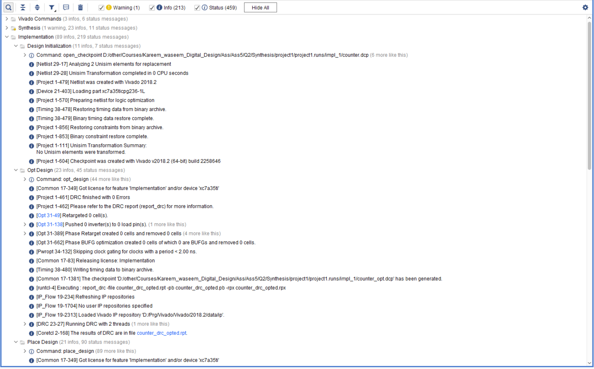

Utilization report

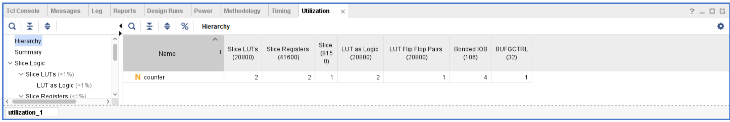

Timing report

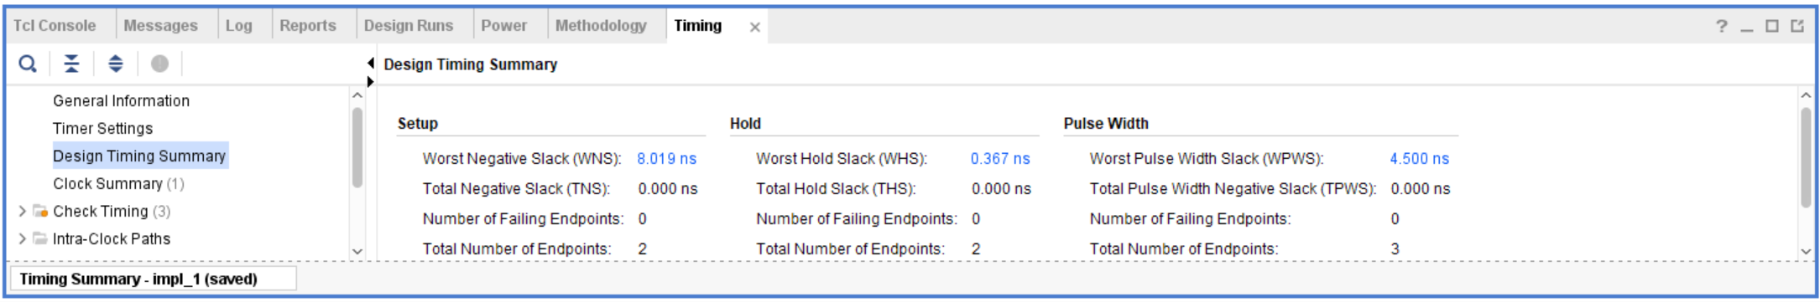

Device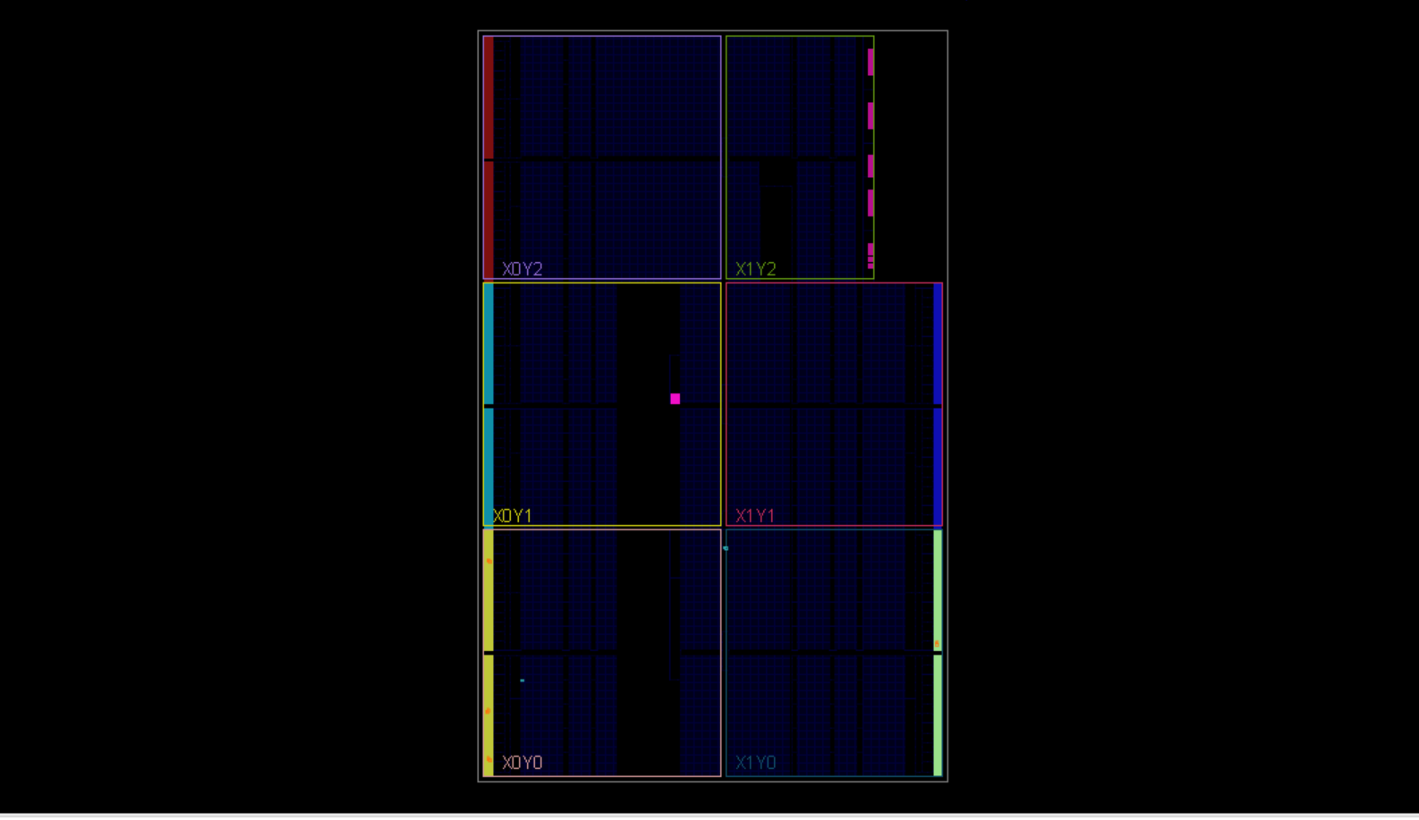

# **9.** **Bitstream**

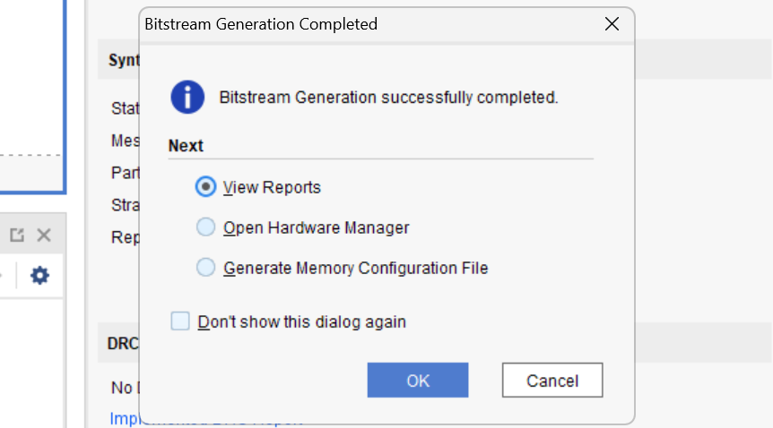

# **10. Linting**

Lint snippet

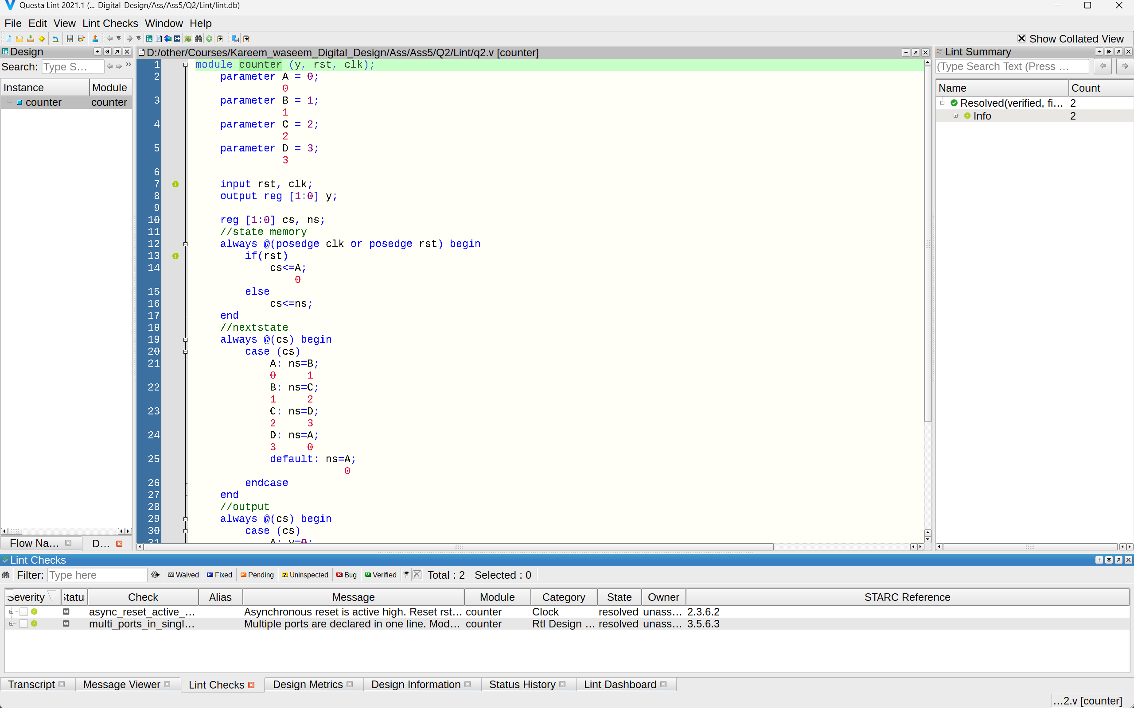

Lint Schematic

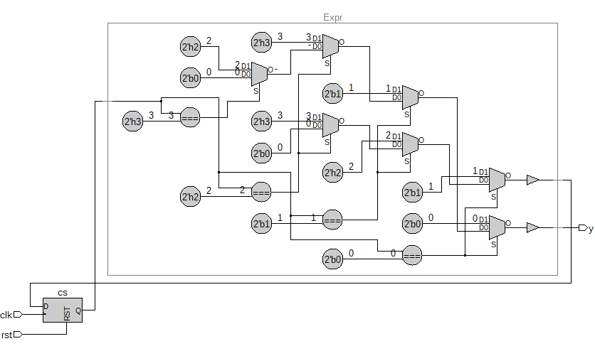

# **3) Q3**

# **1. RTL code**

1. TOP_Module

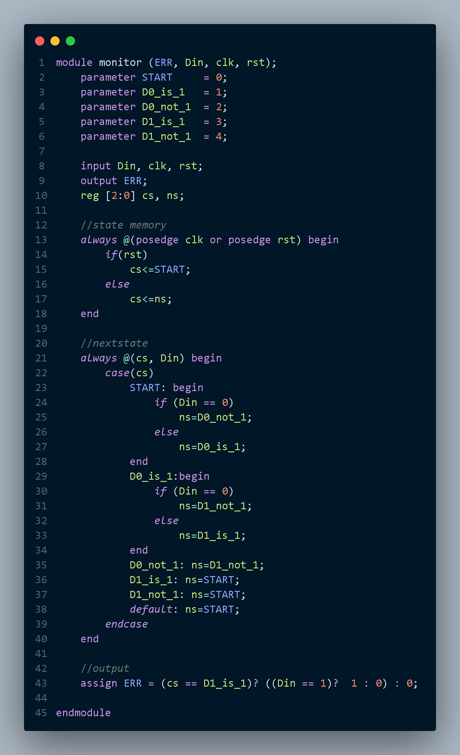

# **2.** **Testbench code**

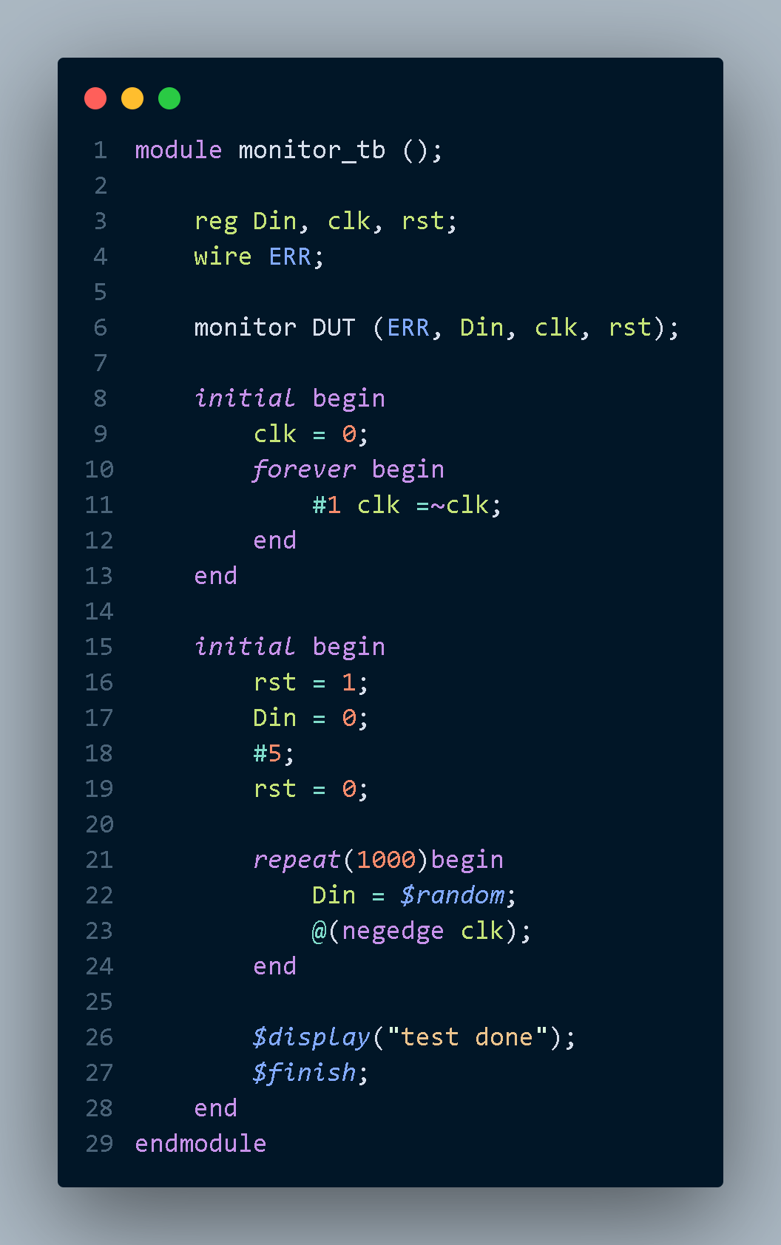

# **3.** **Do file**

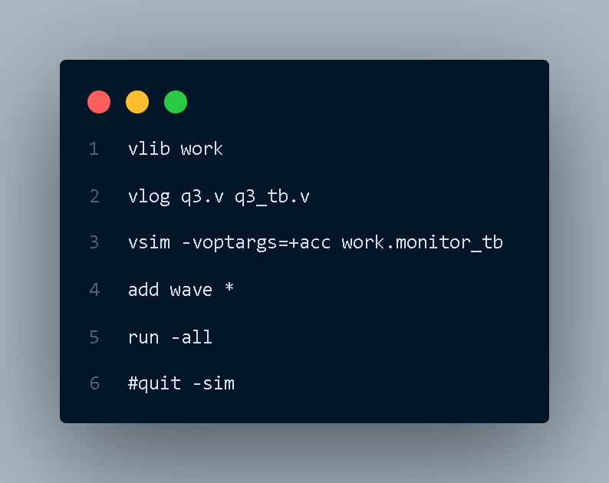

**4.** **QuestaSim Snippets**

Messages Snippet

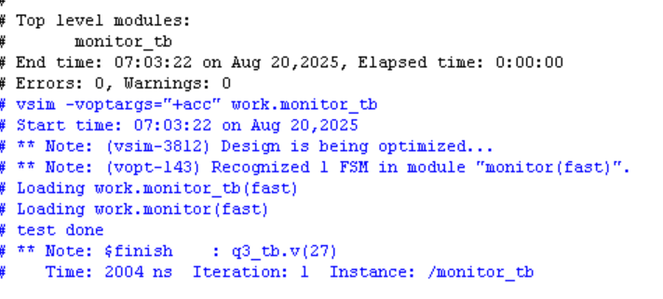

Waveform Snippet





# **5.** **Constraint File**

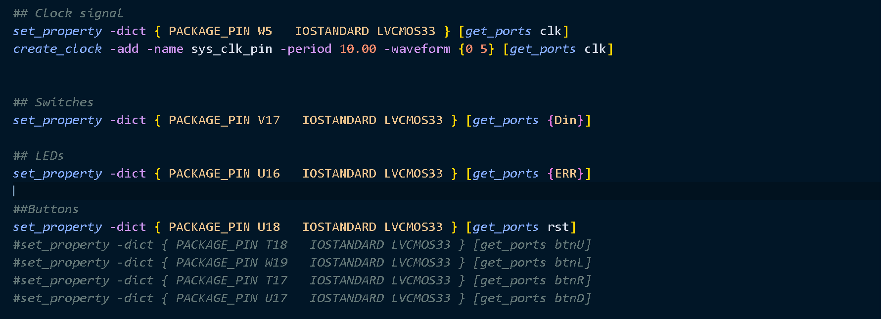

# **6.** **Elaboration**

Message tab

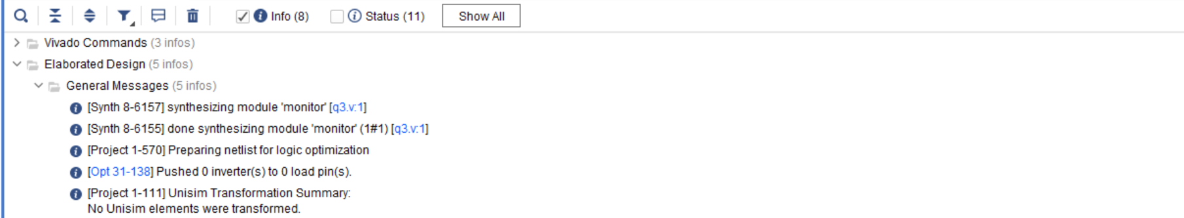

Schematic

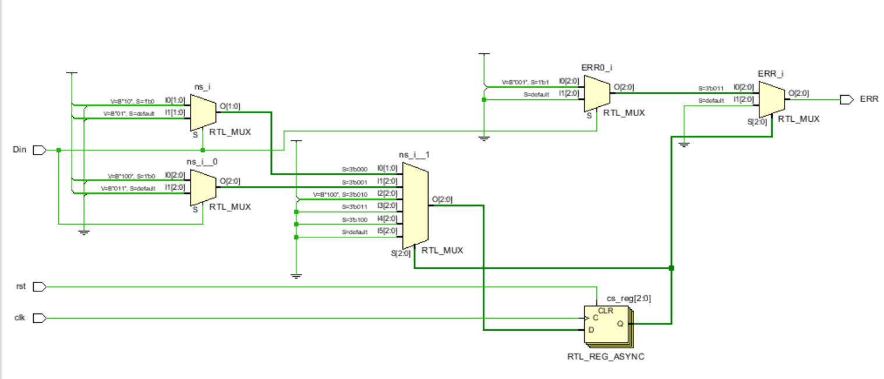

# **7.** **Synthesis**

Message Tab

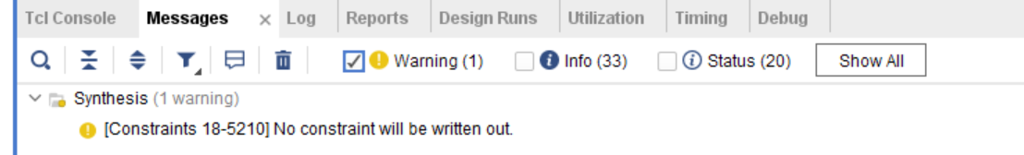

Utilization report

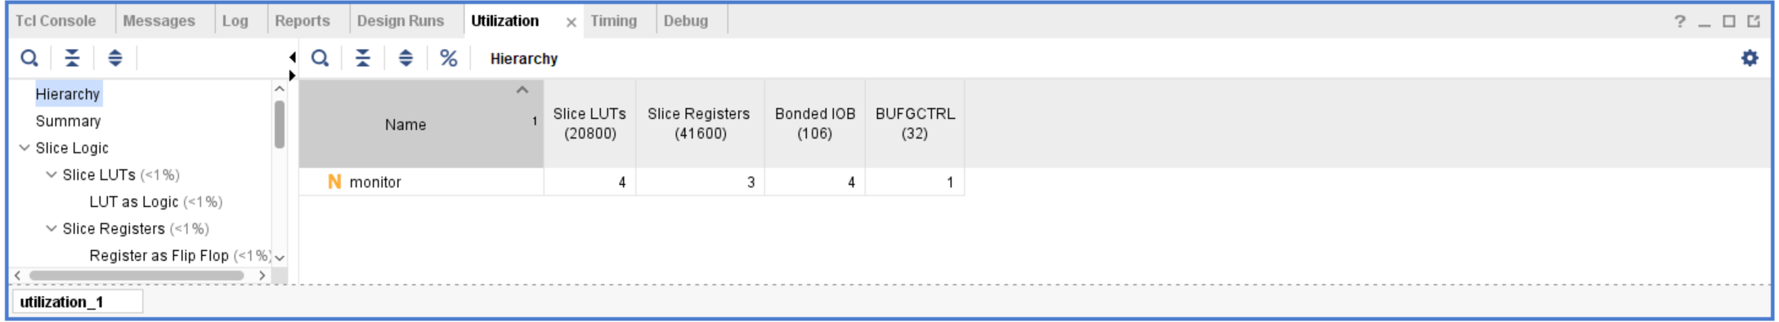

Timing report

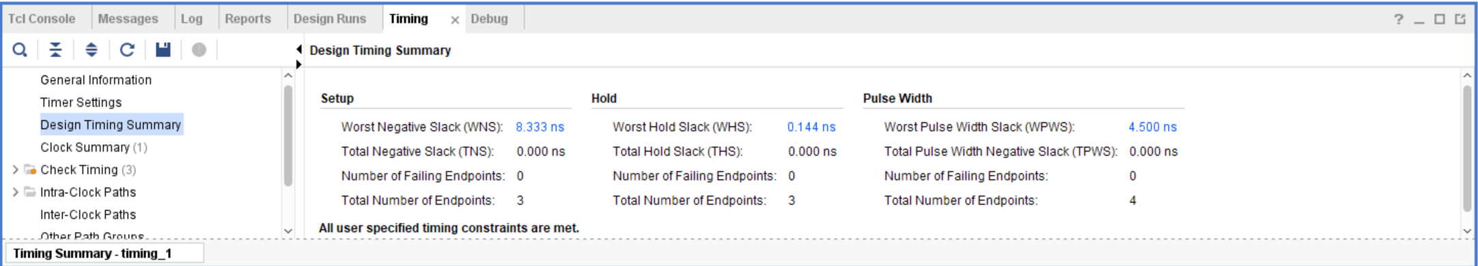

Schematic

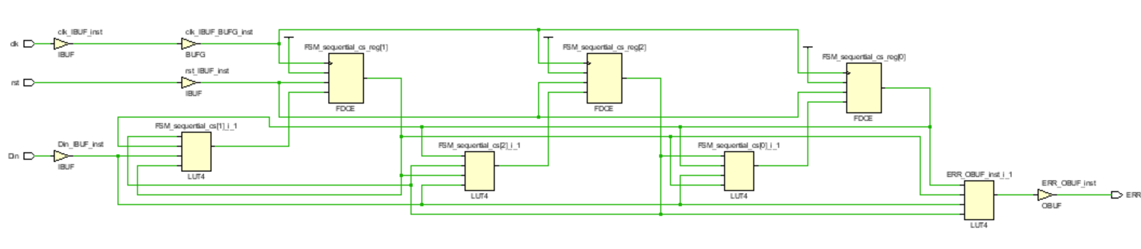

## Netlist

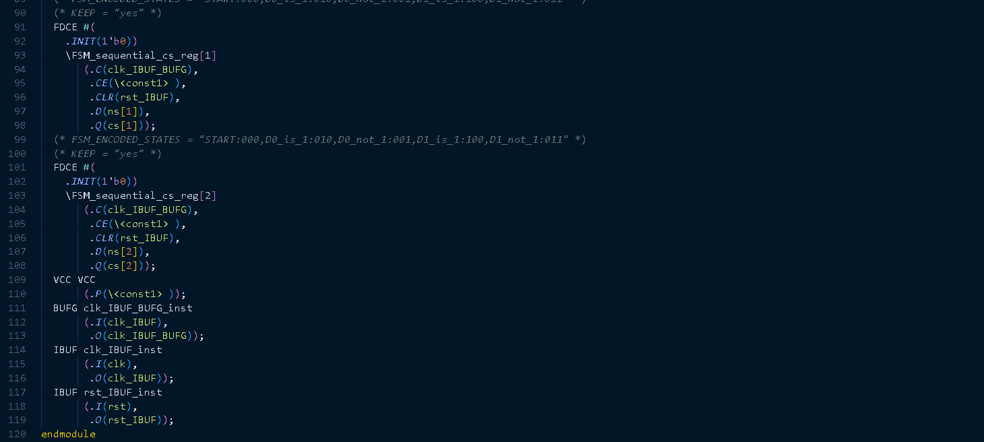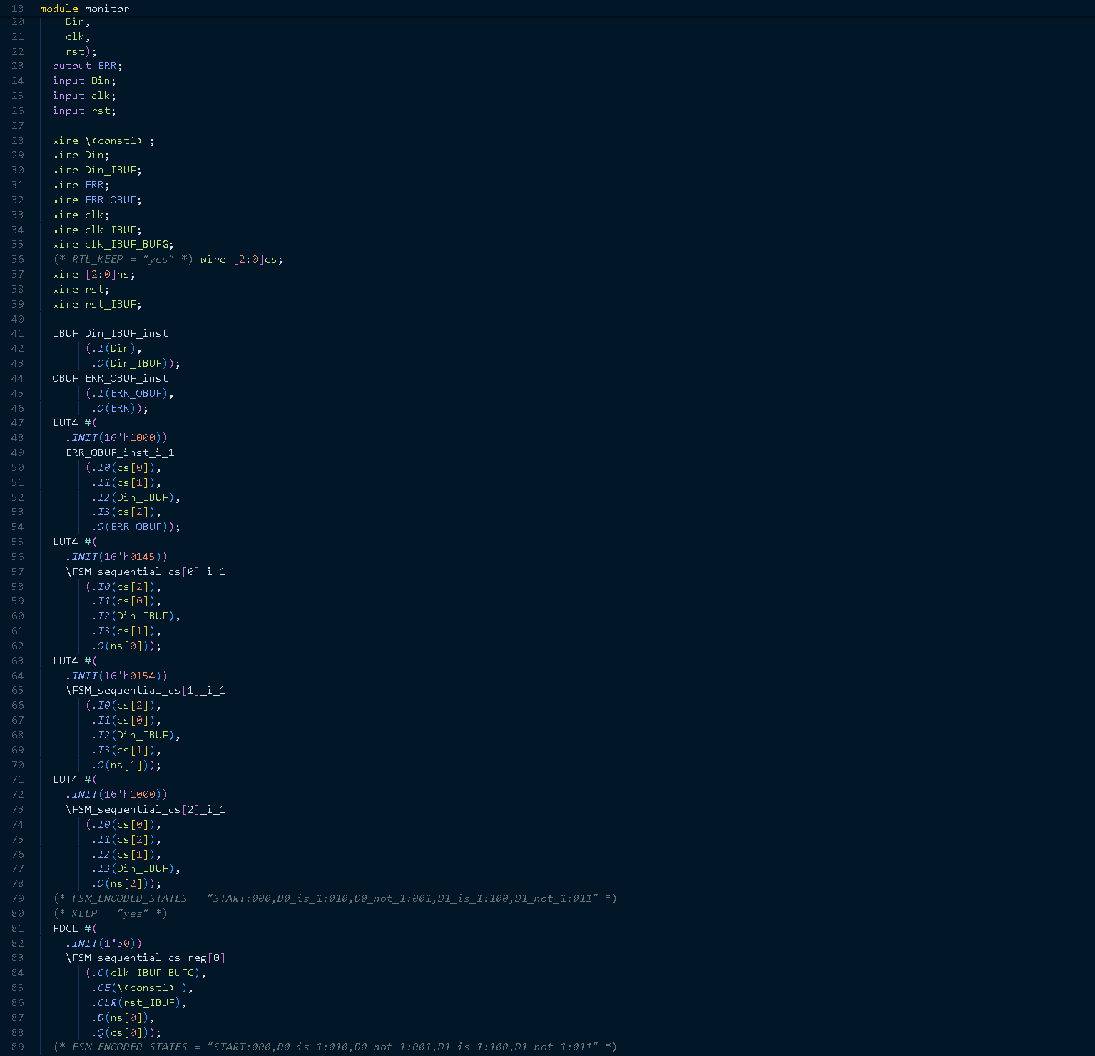

# **8.** **Implementation**

Message Tab

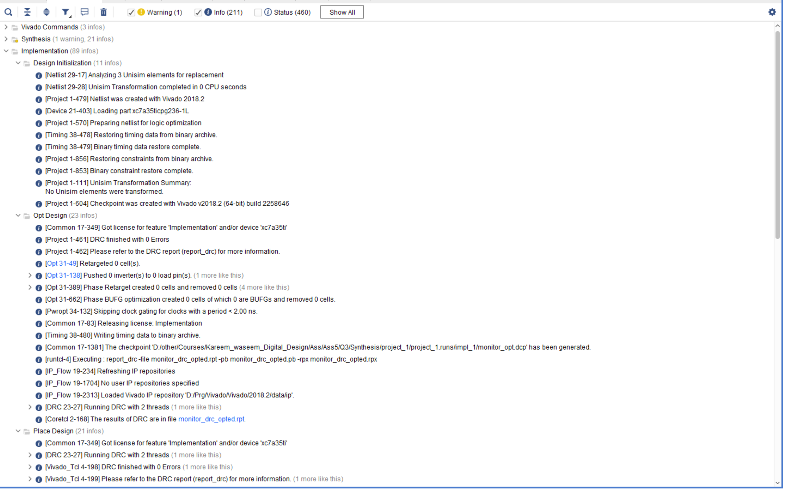

Utilization report

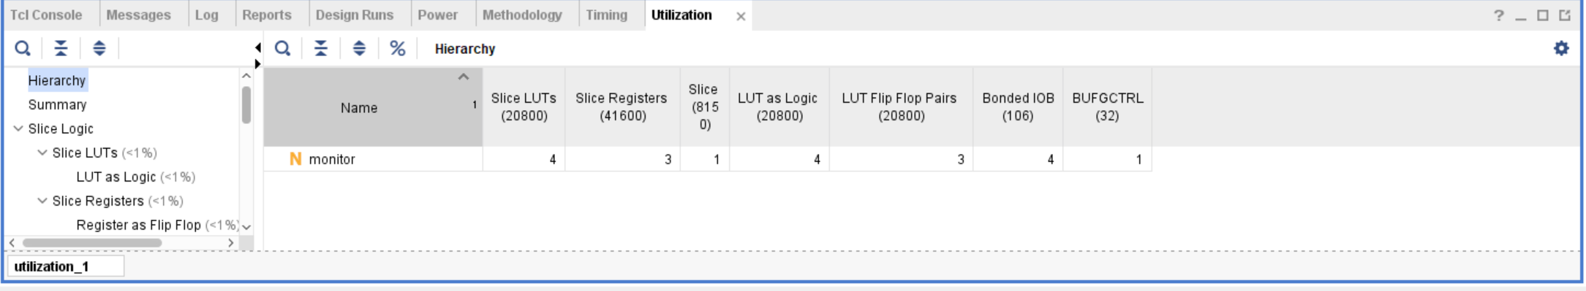

Timing report

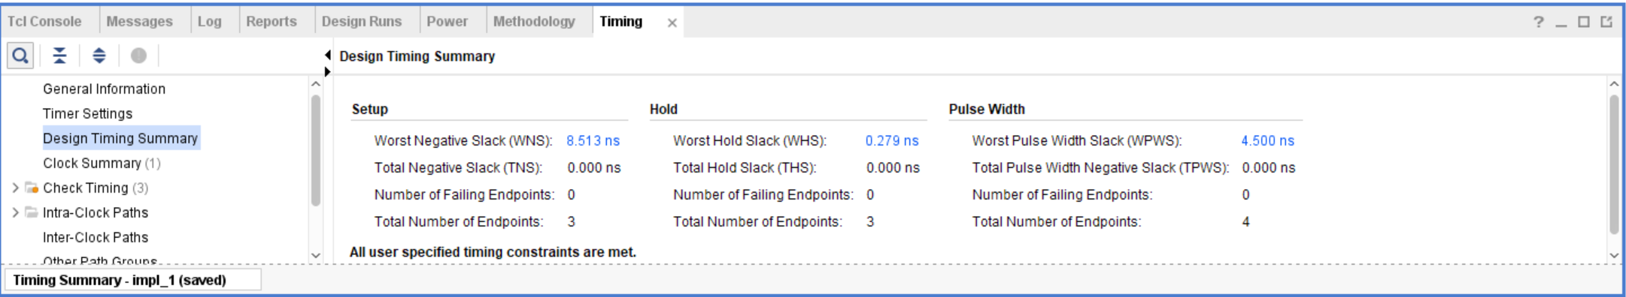

Device

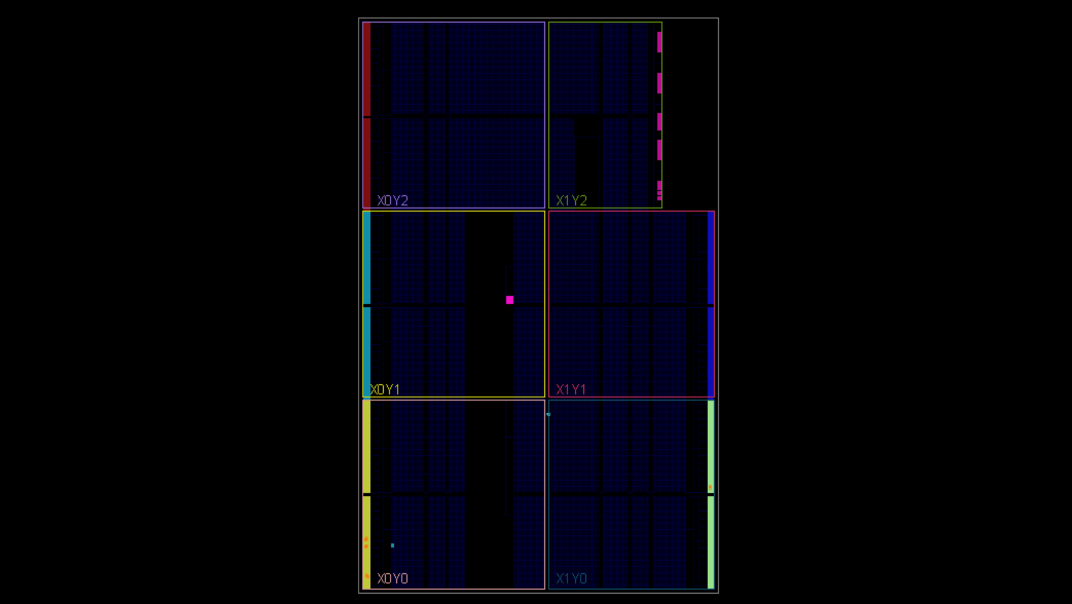

# **Comment**

One hot encoding:

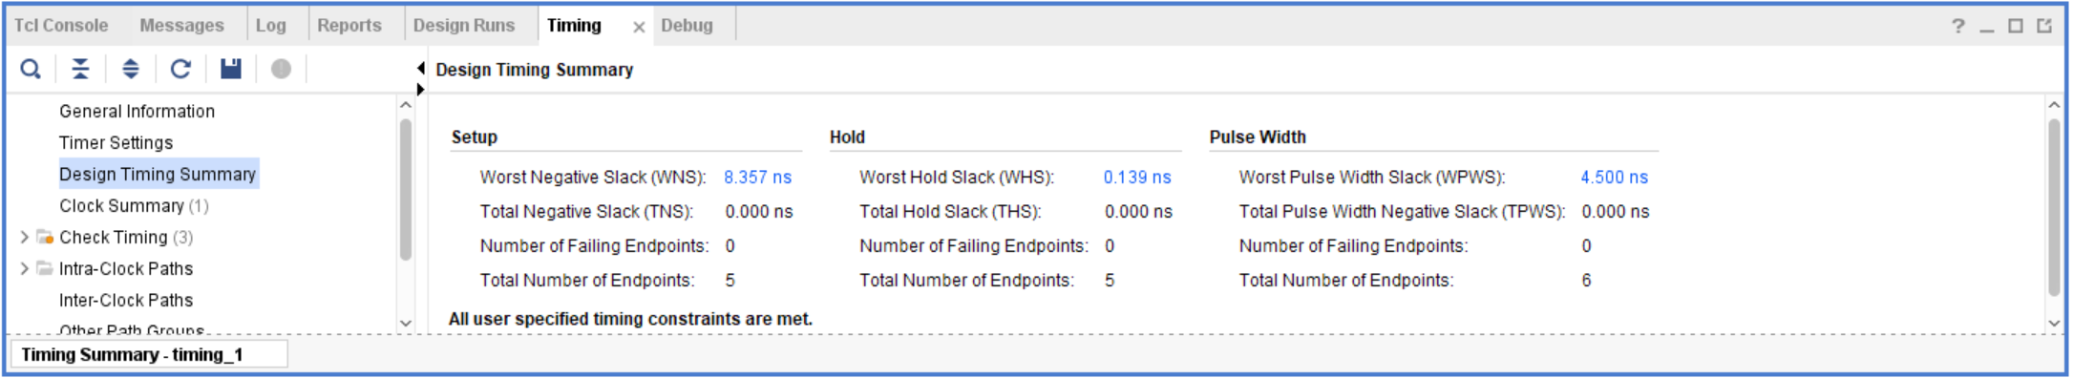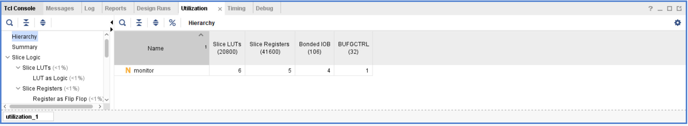

Gray encoding:

Same as the binary

It appears that best encoding in highest frequency for the design will be one hot encoding, but for minimum area could be gray or binary encoding.

**10. Bitstream**

# **9. Linting**

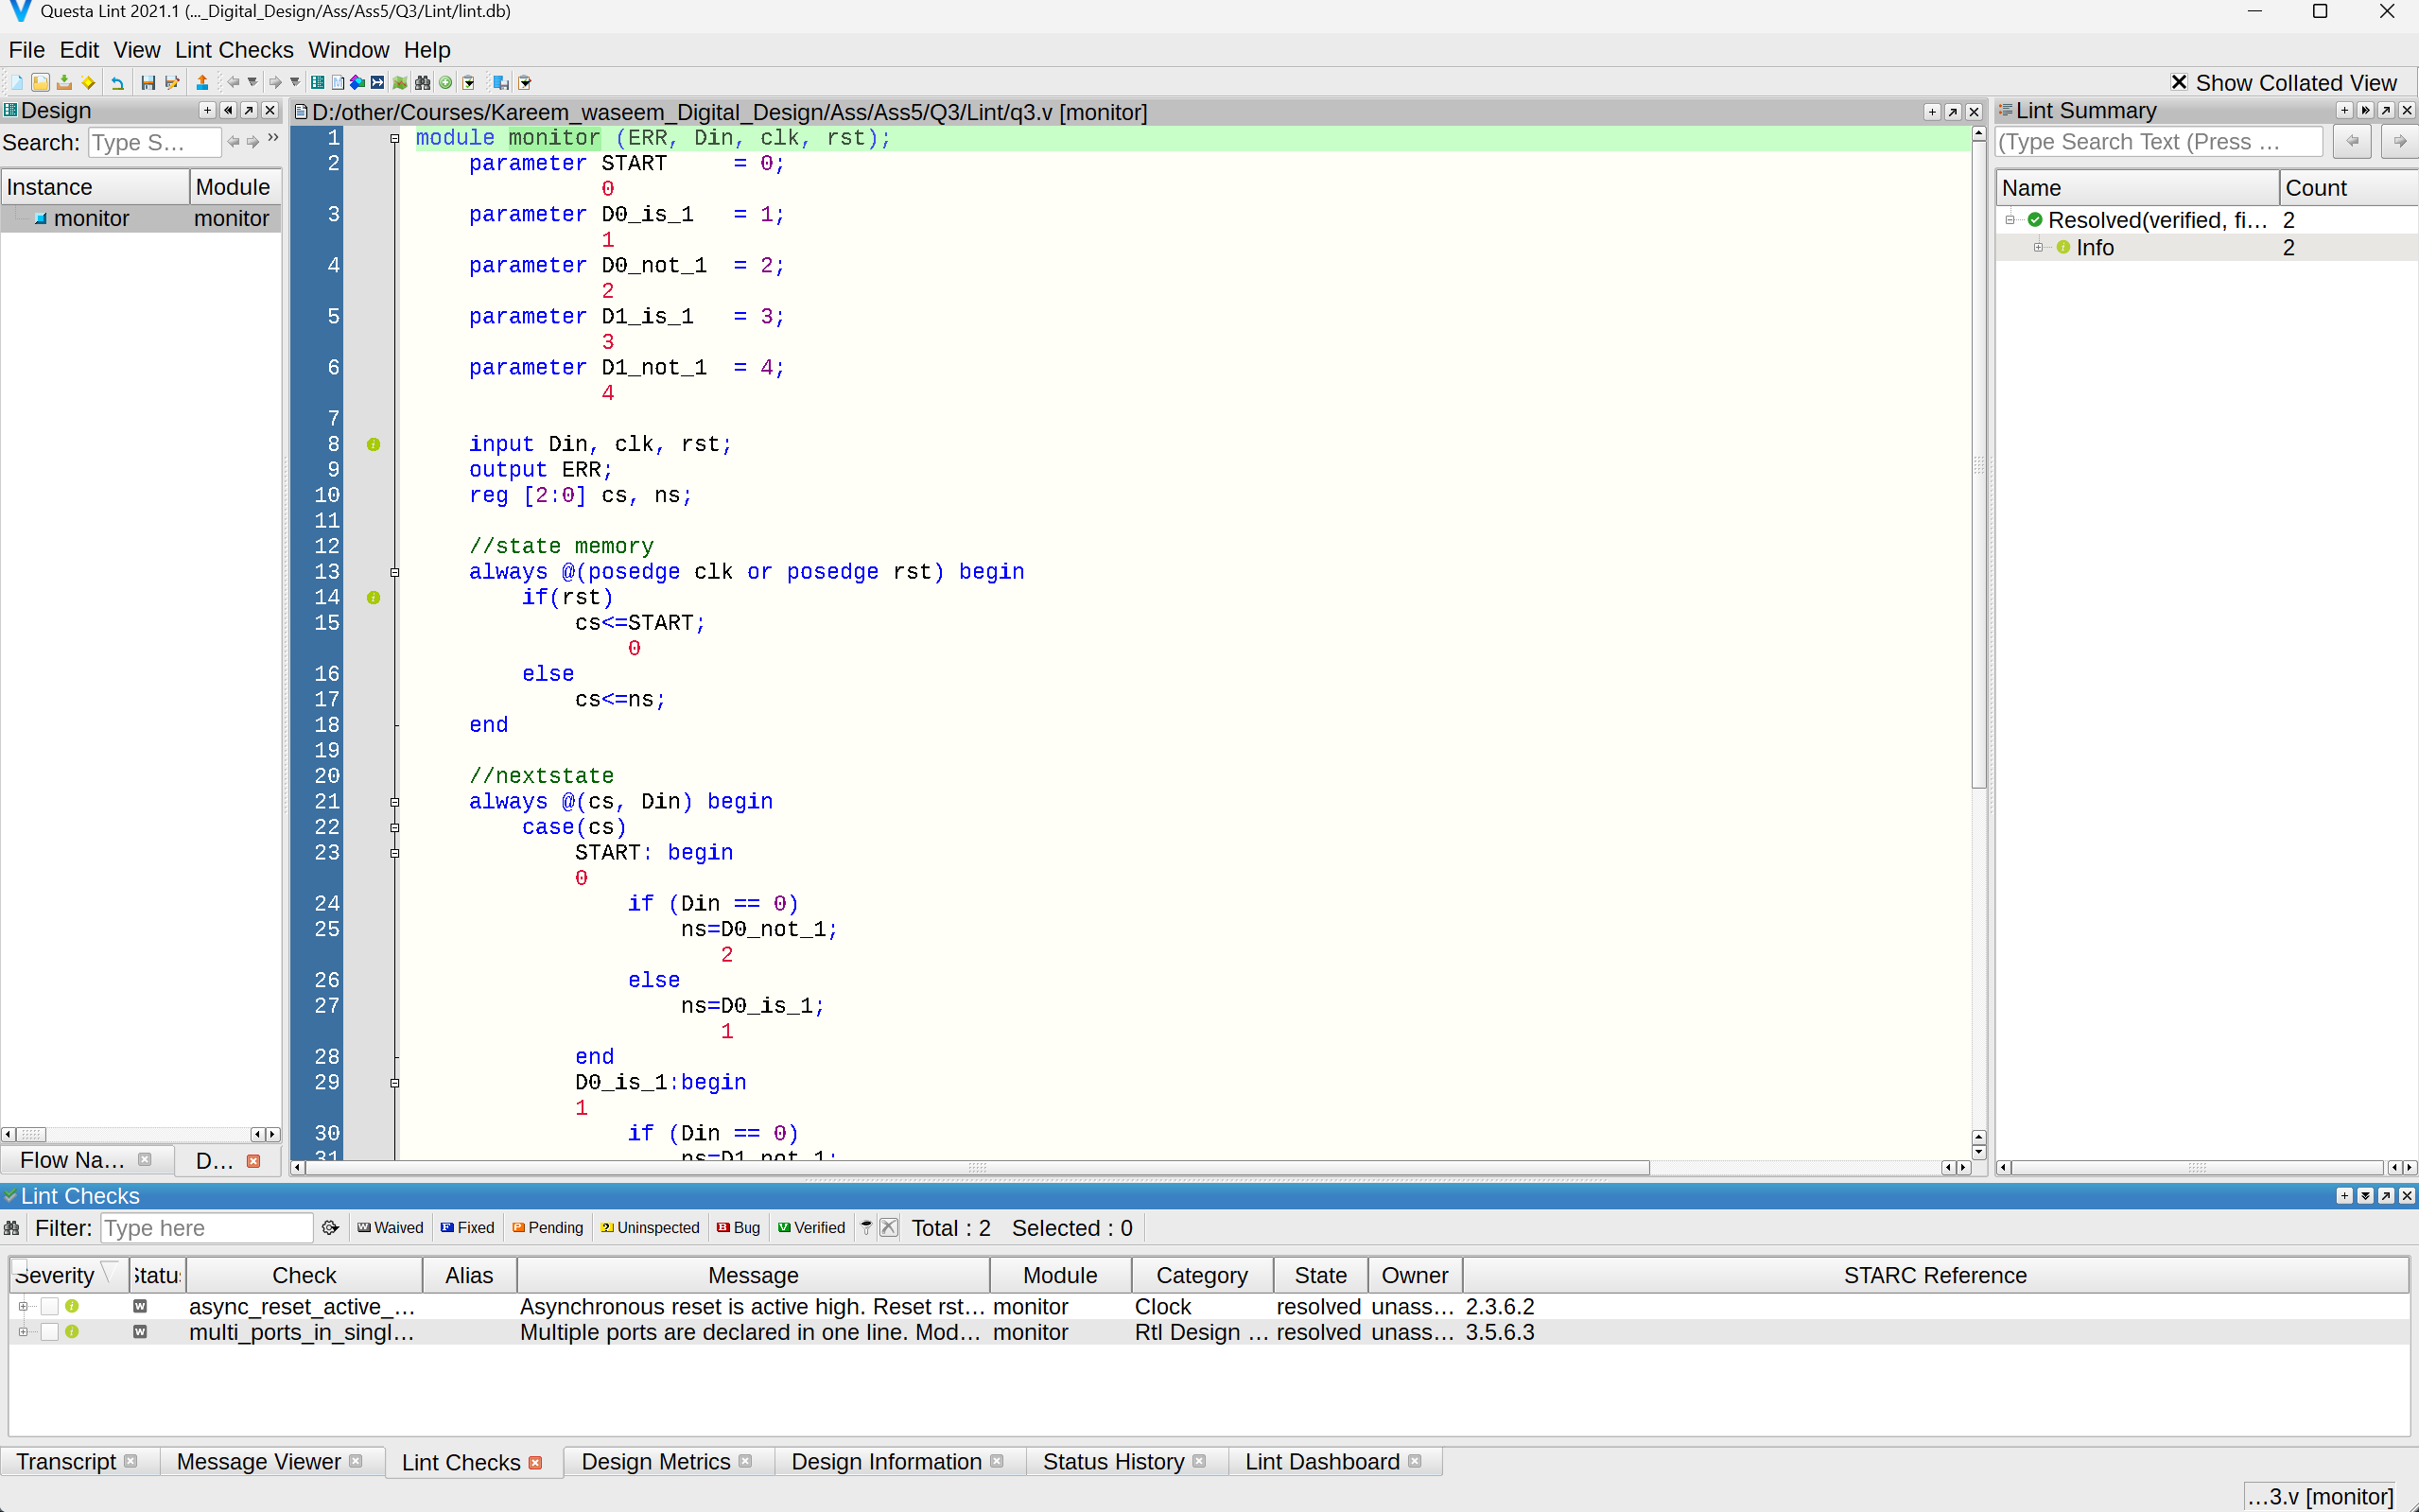Lint snippet

Lint Schematic

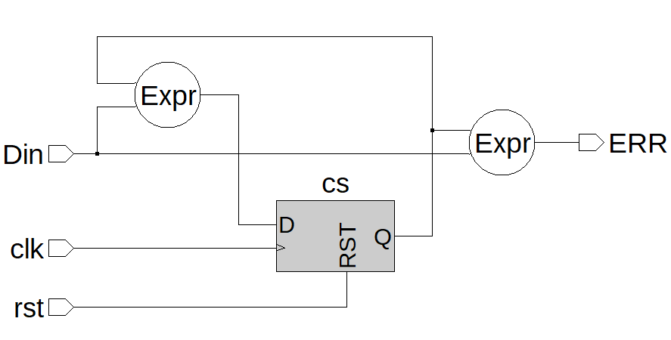

# **4) Q4**

# **1. RTL code**

1. TOP_Module

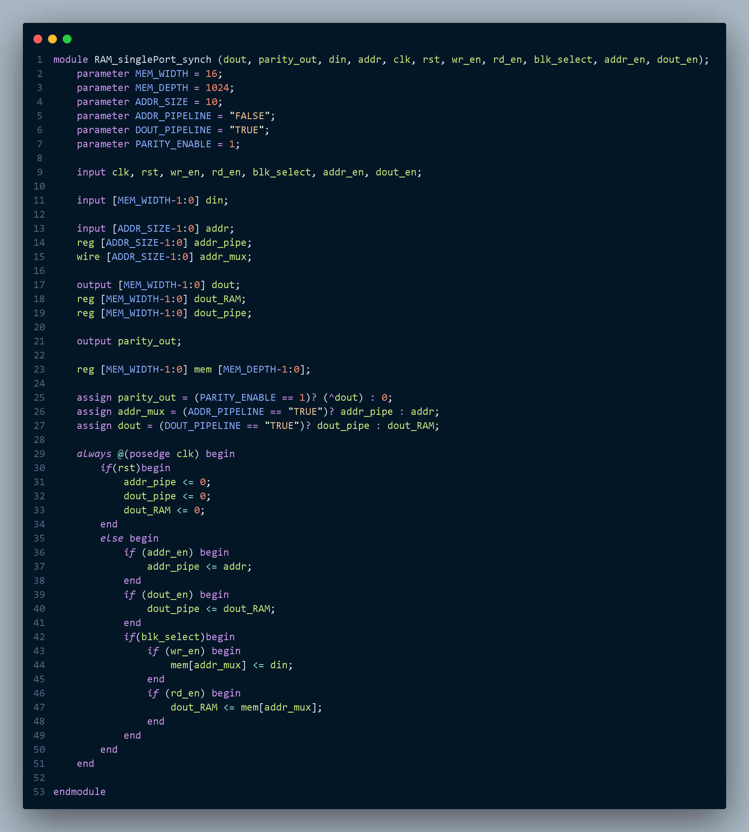

# **2.** **Testbench code**

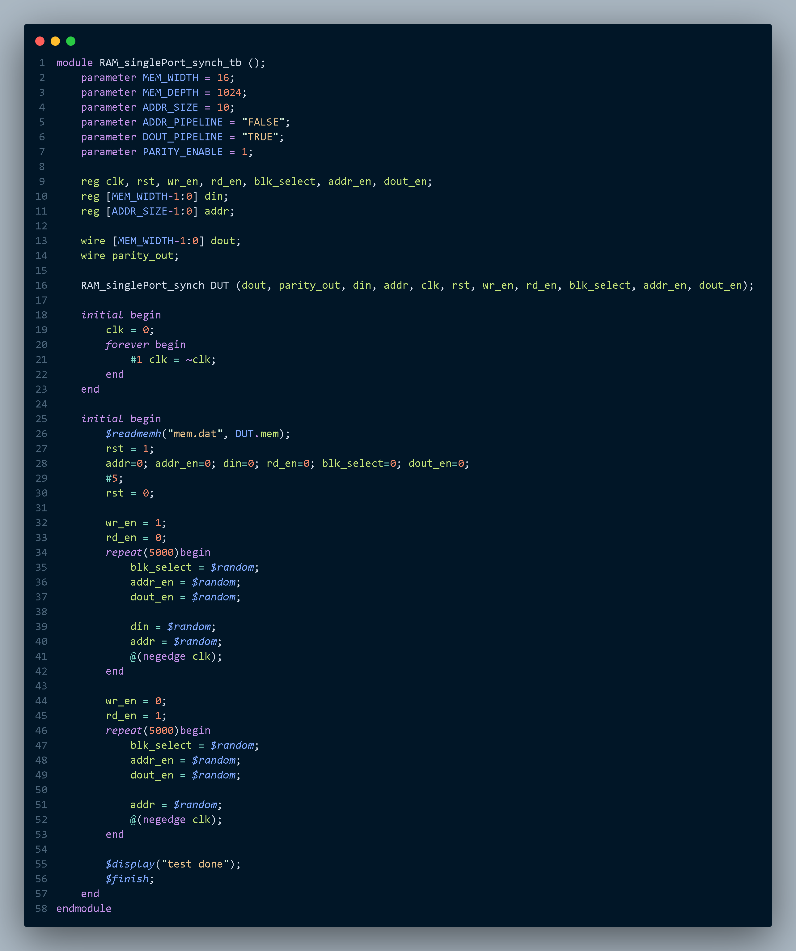

# **3.** **Do file**

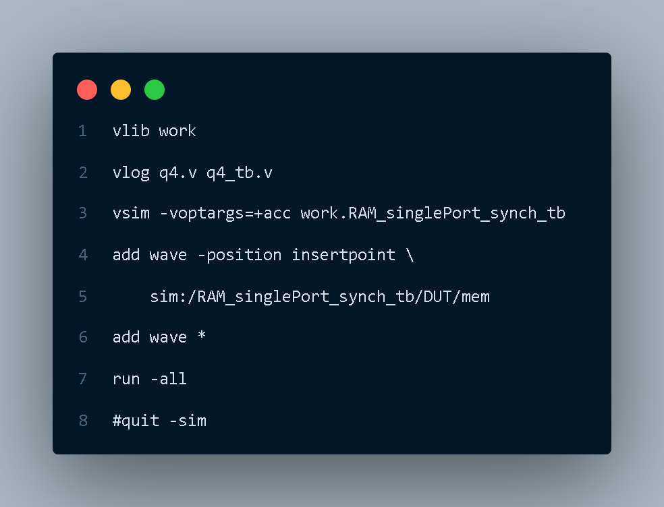

**4.** **QuestaSim Snippets**

Messages Snippet

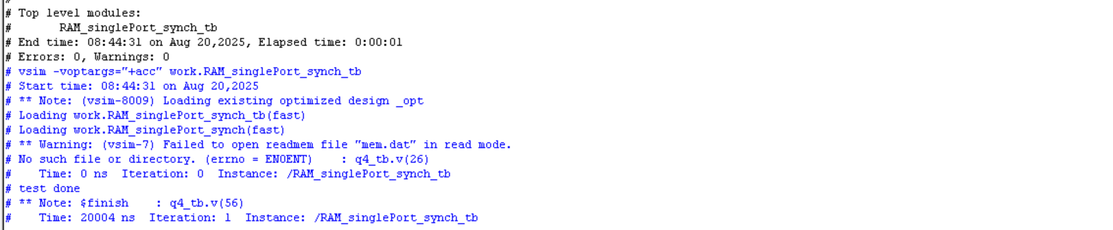

Waveform Snippet

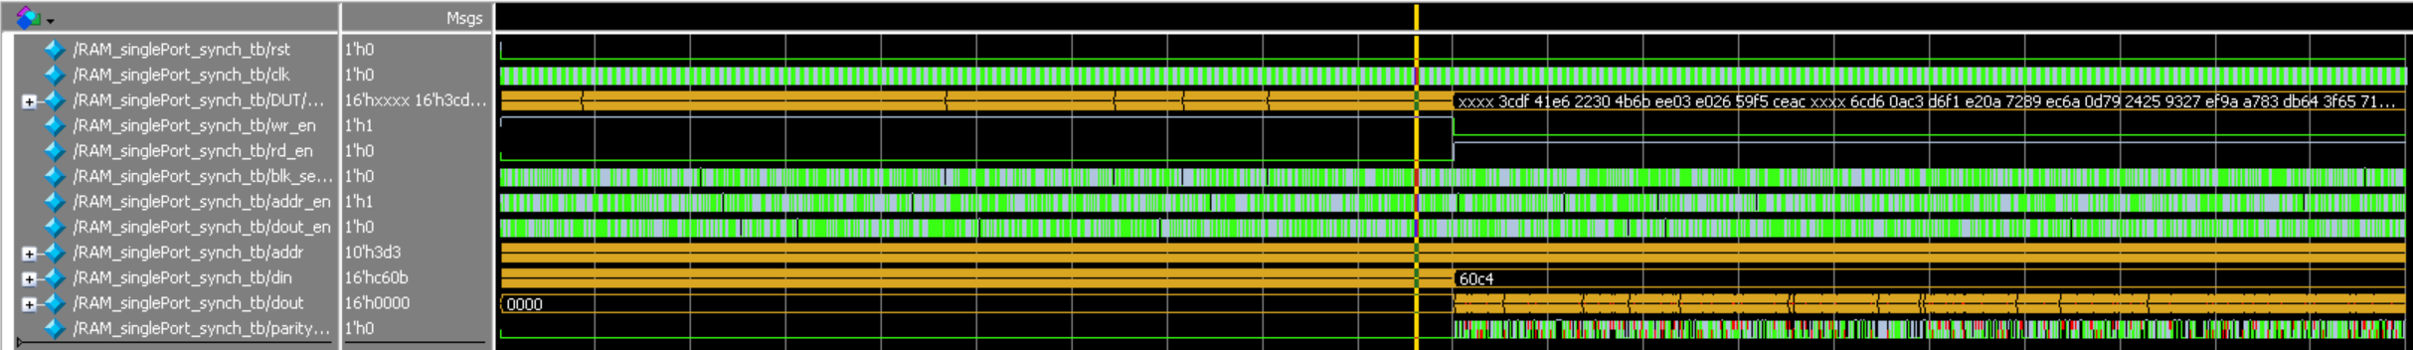

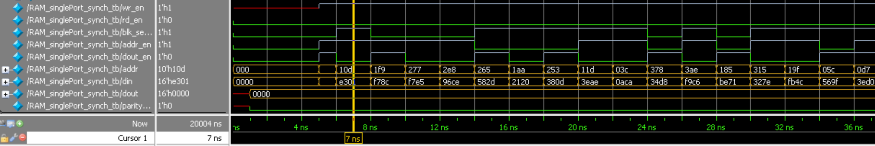

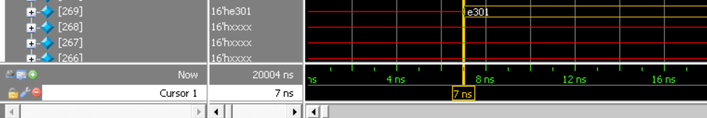

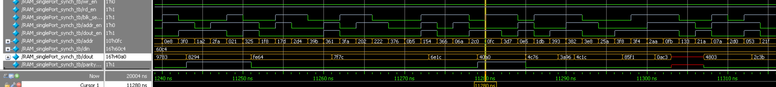



# **5.** **Constraint File**



# **6.** **Elaboration**

Message tab

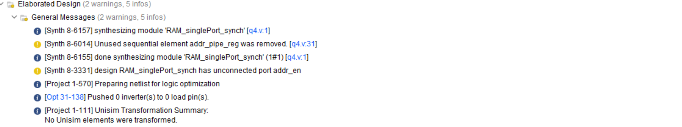

Schematic

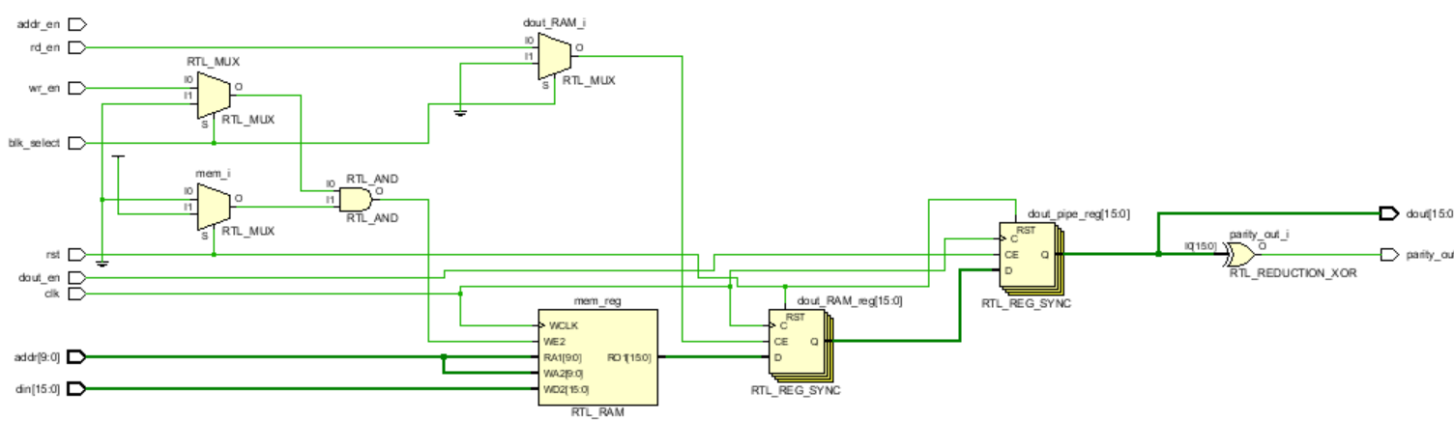

# **7.** **Synthesis**

Message Tab

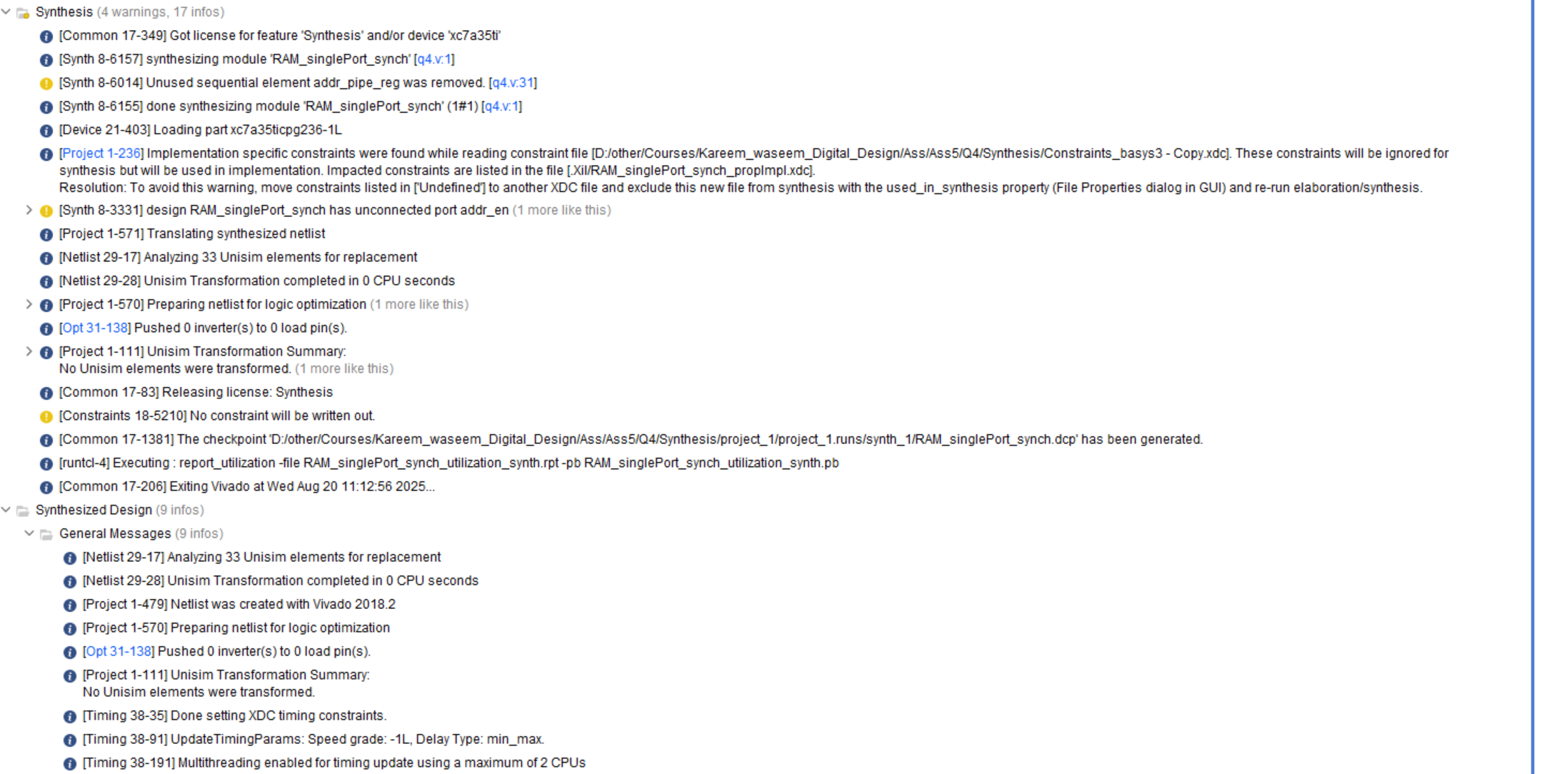

Utilization report

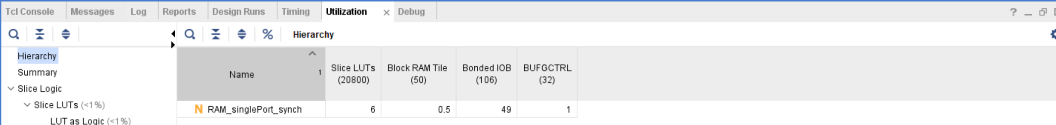

Timing report

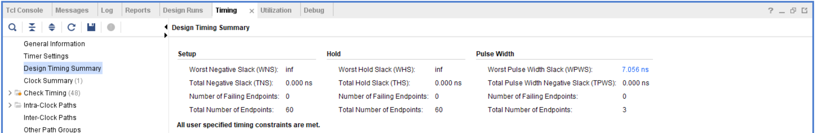

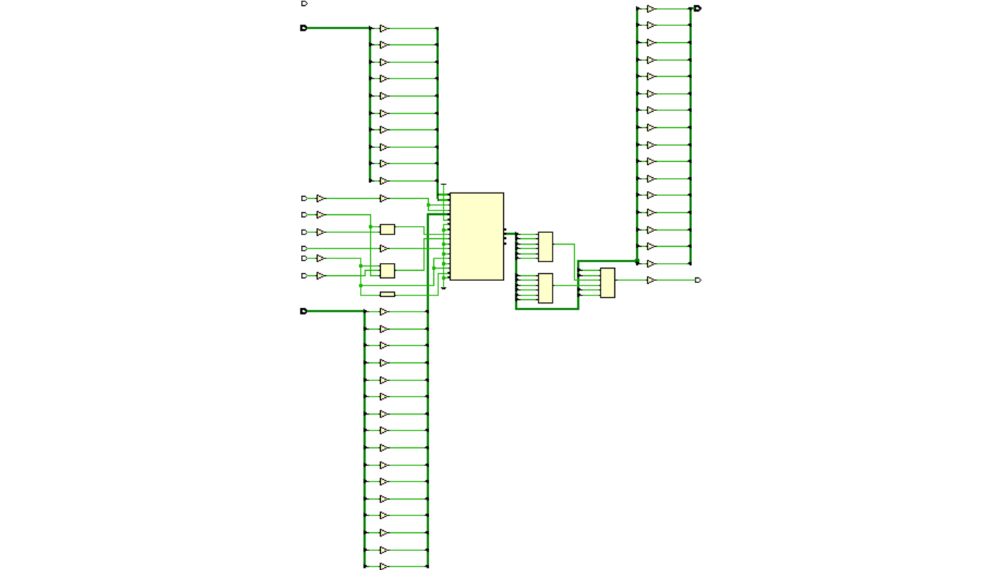Schematic

## Netlist

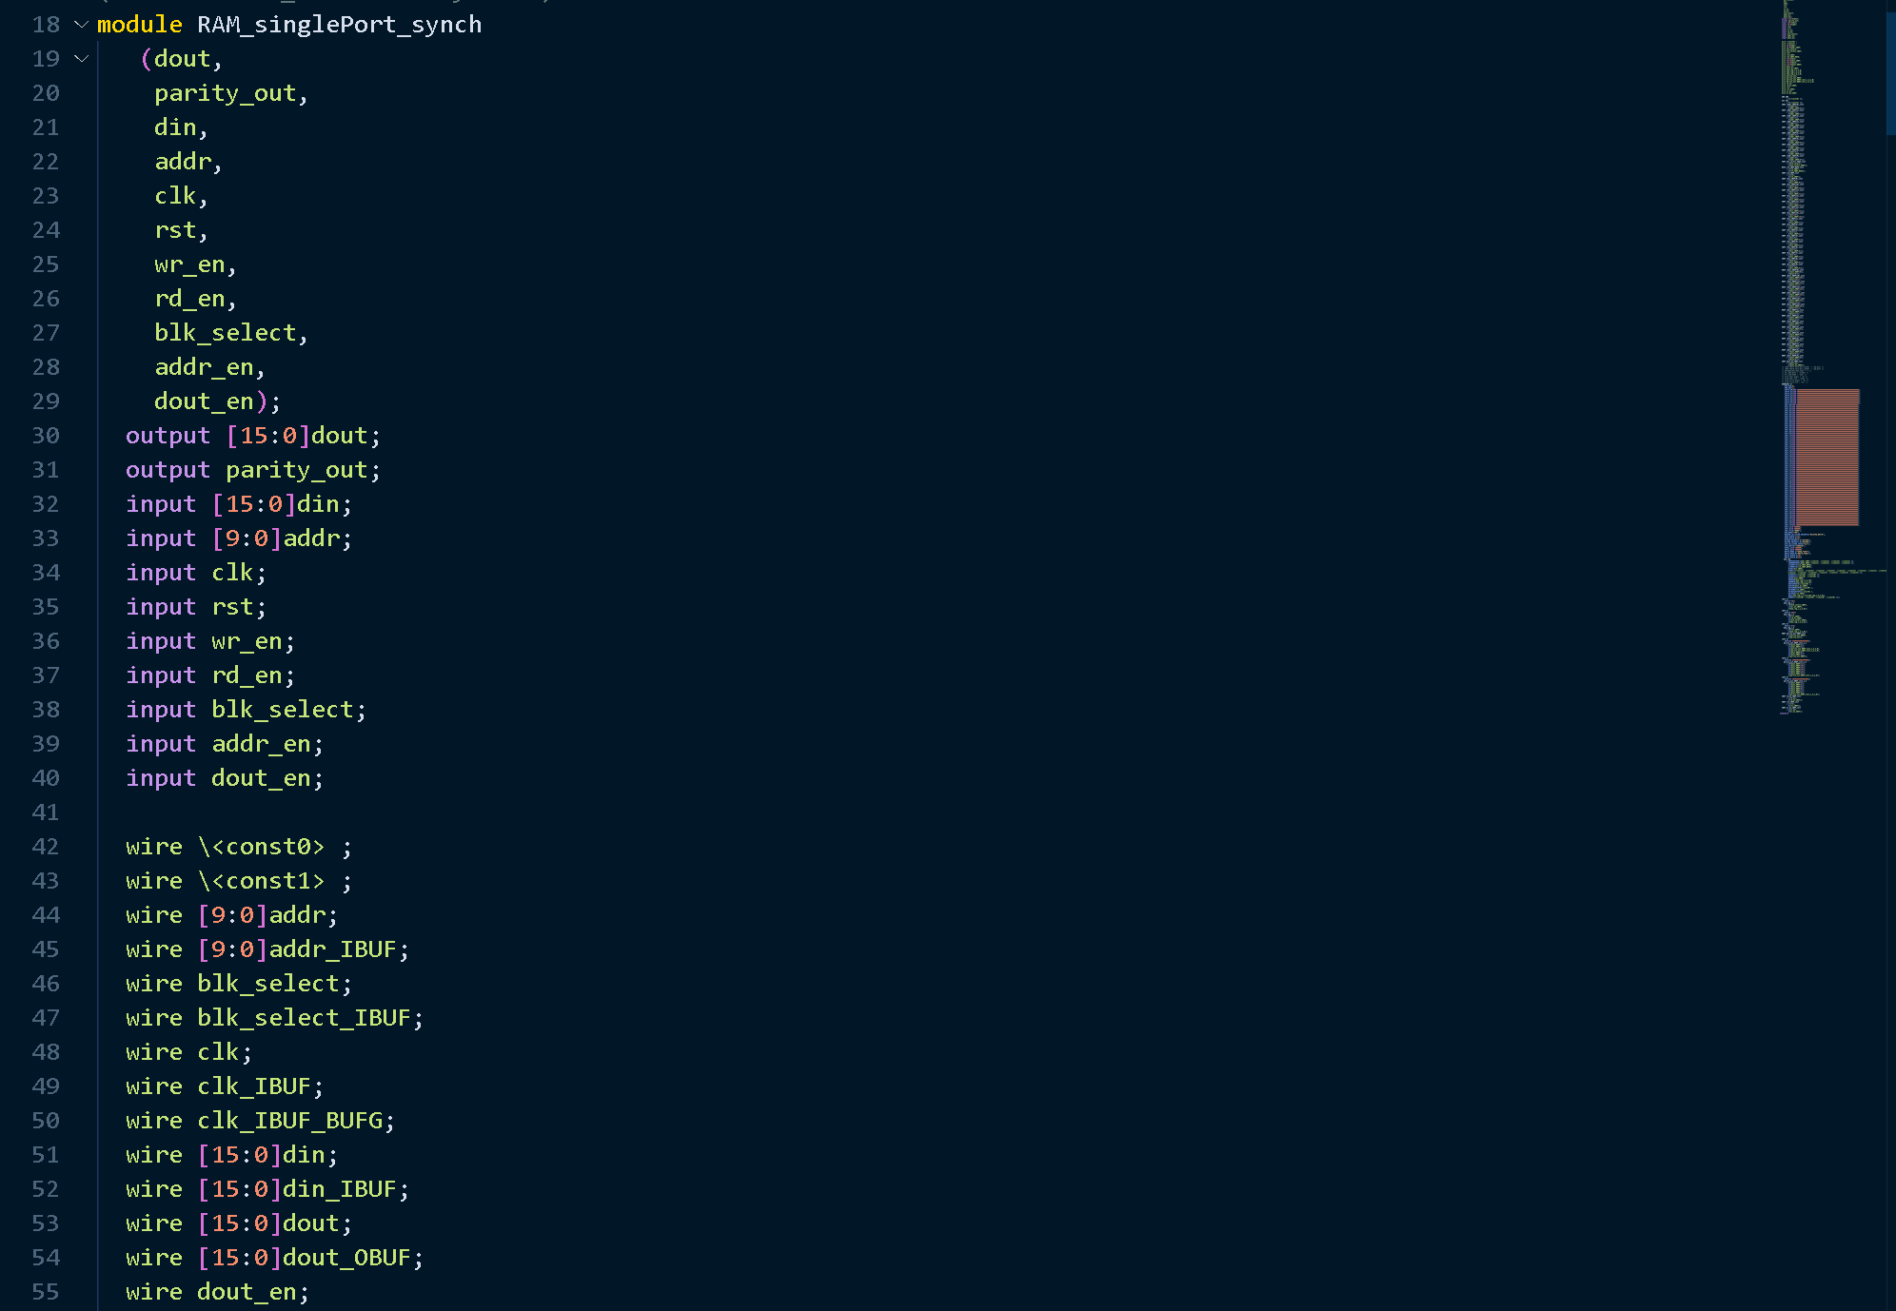

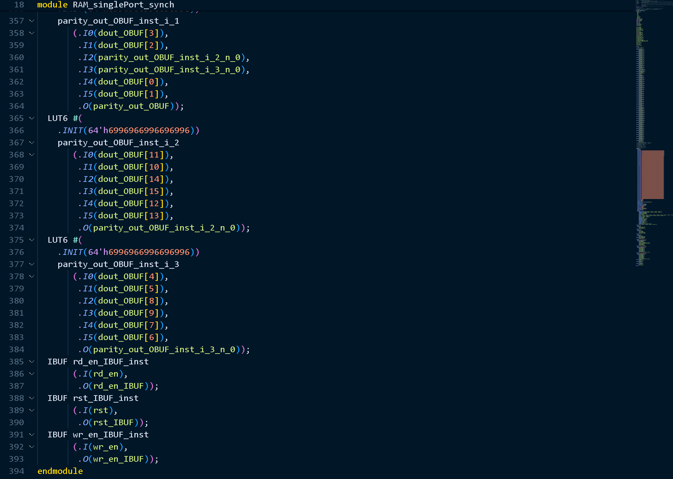

# **9. Linting**

Lint snippet

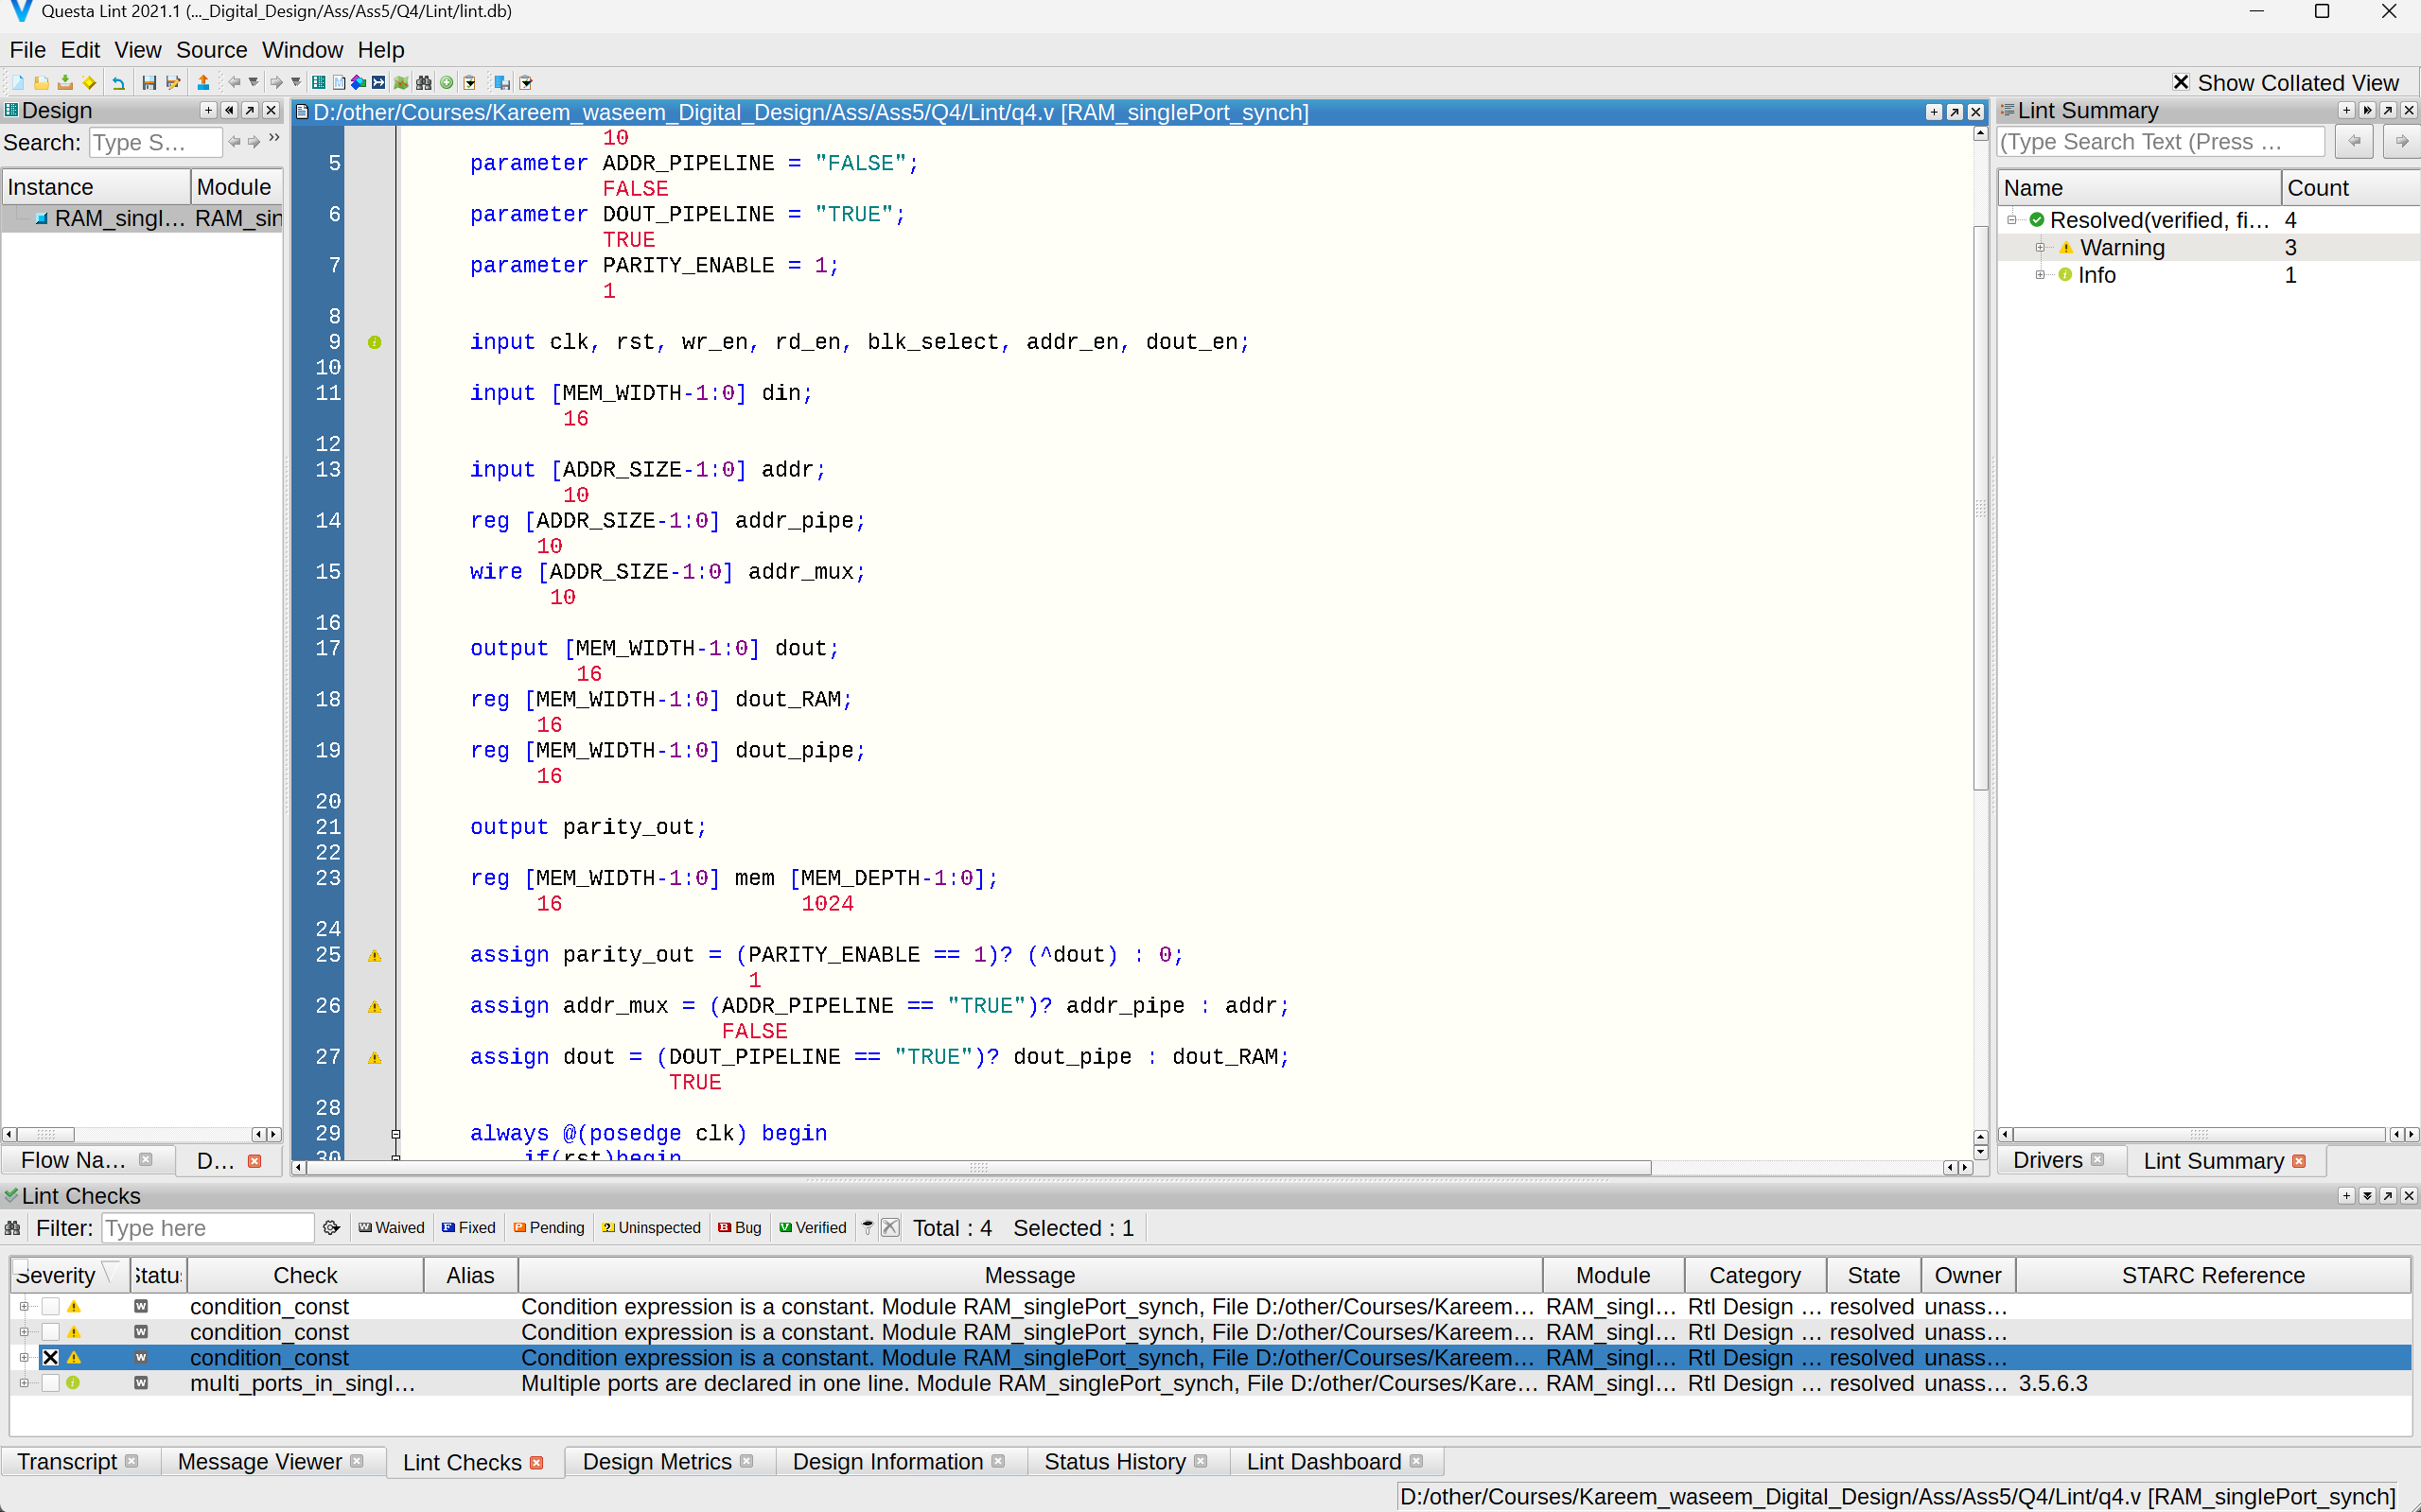

Lint Schematic

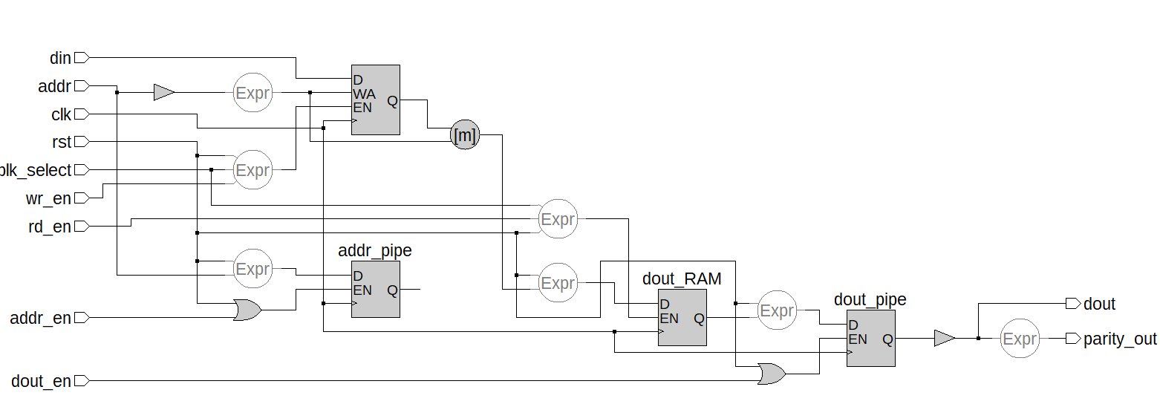

# **5) Q5**

# **1. RTL code**

1. TOP_Module

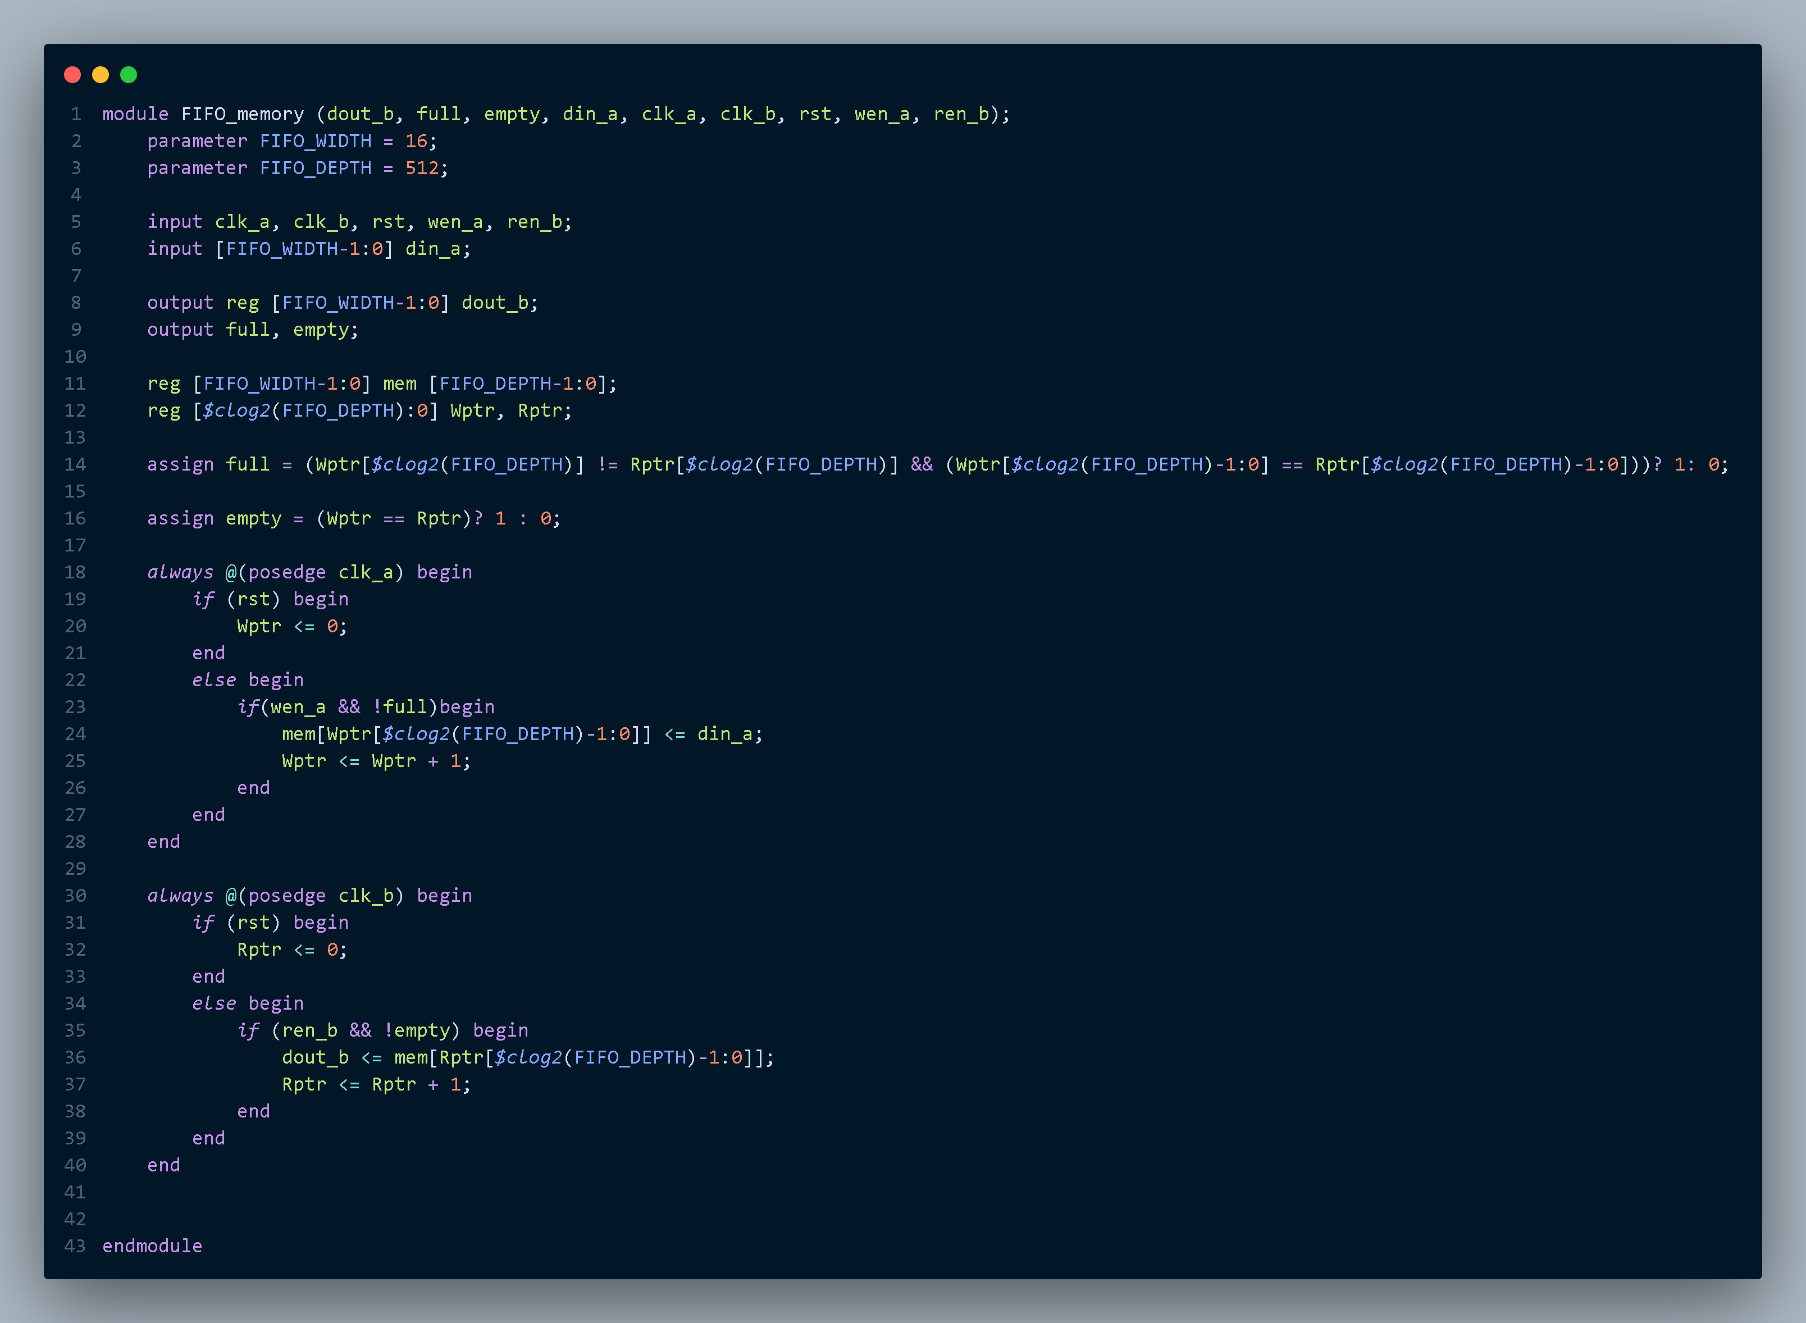

**2.** **Testbench code**

**3.** **Do file**

**4.** **QuestaSim Snippets**

Messages Snippet

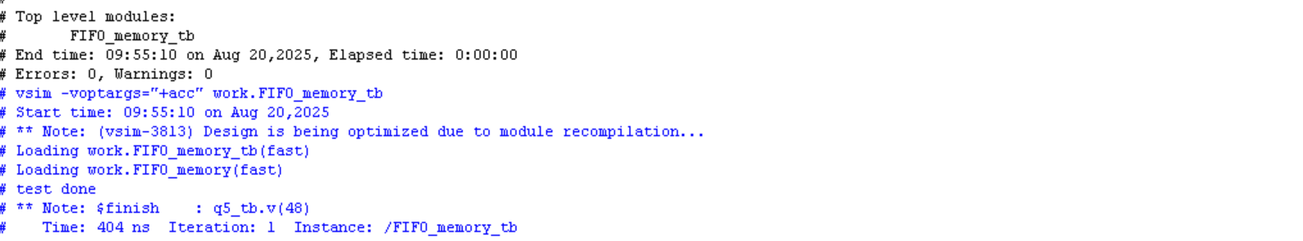

Waveform Snippet

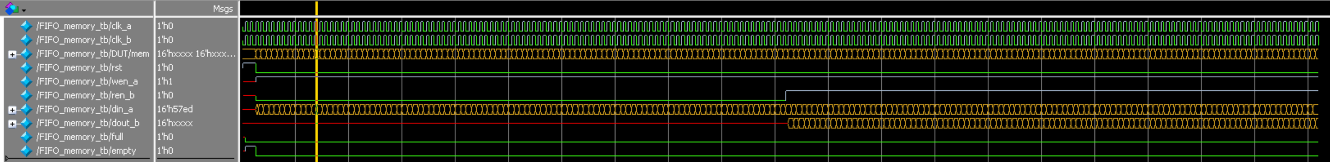

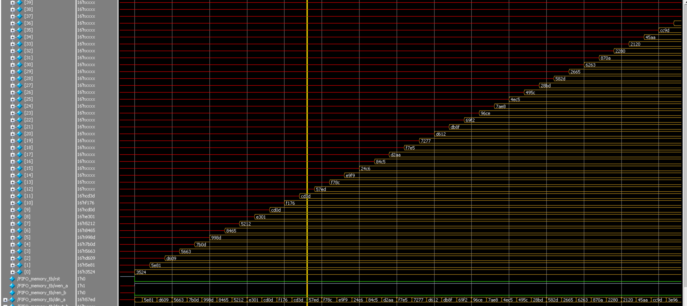

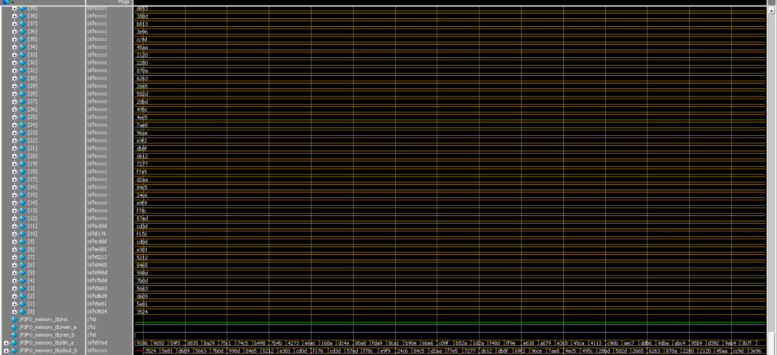

# **5.** **Constraint File**

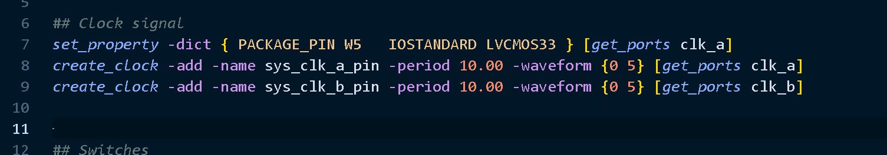

# **6.** **Elaboration**

Message tab

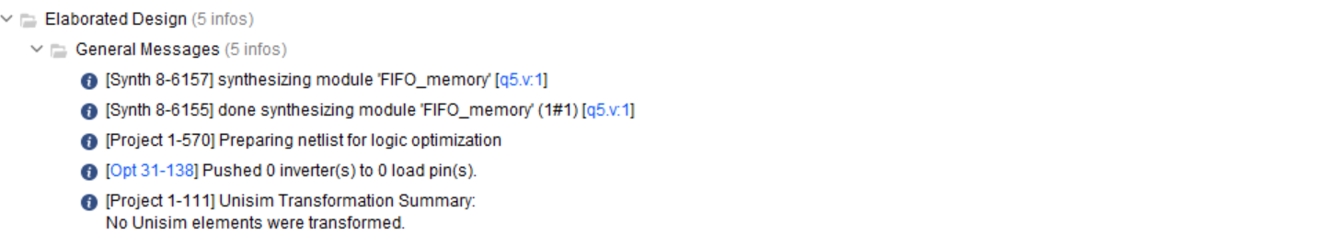

Schematic

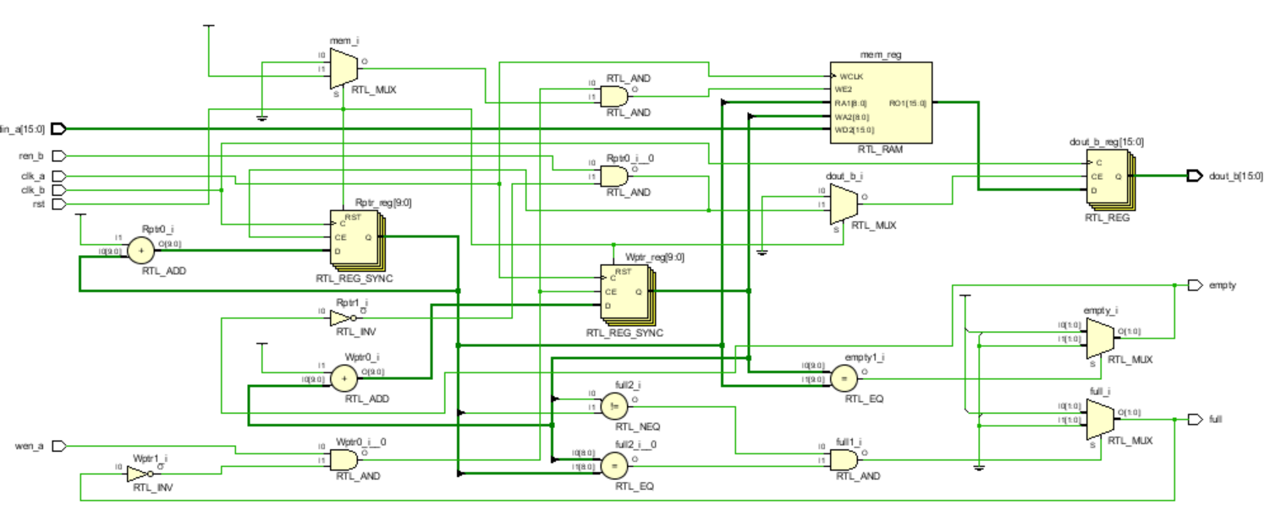

# **7.** **Synthesis**

Message Tab

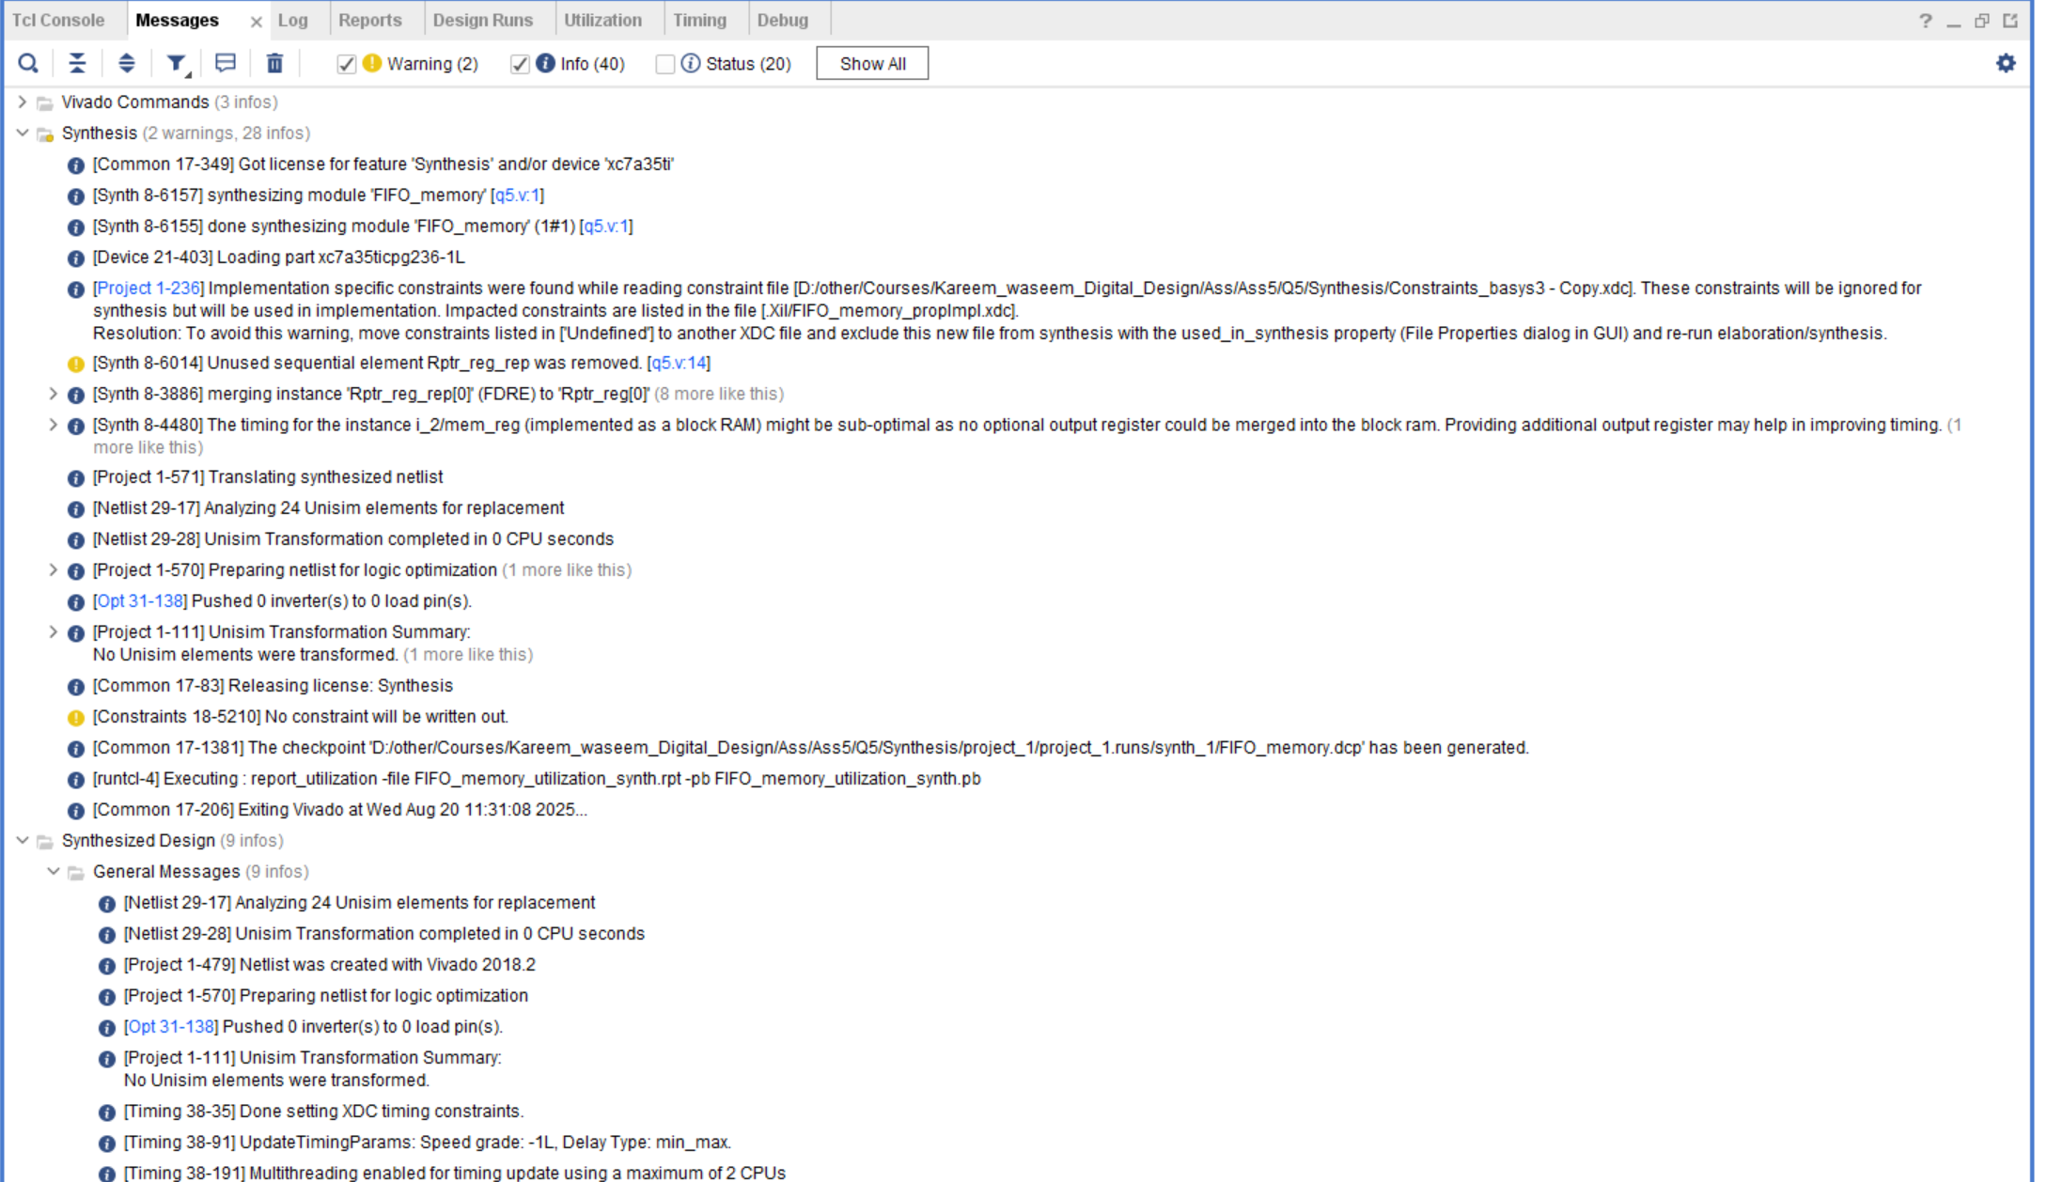

Utilization report

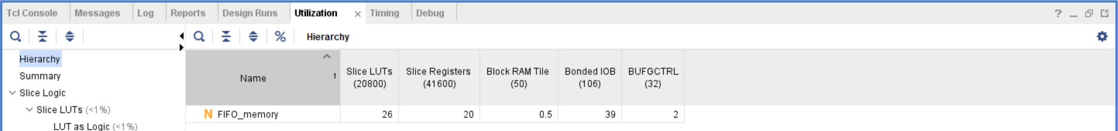

Timing report

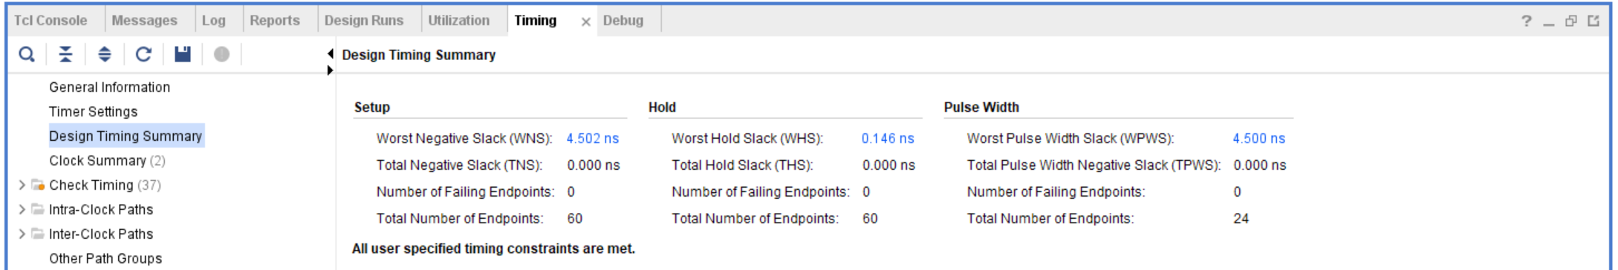

Schematic

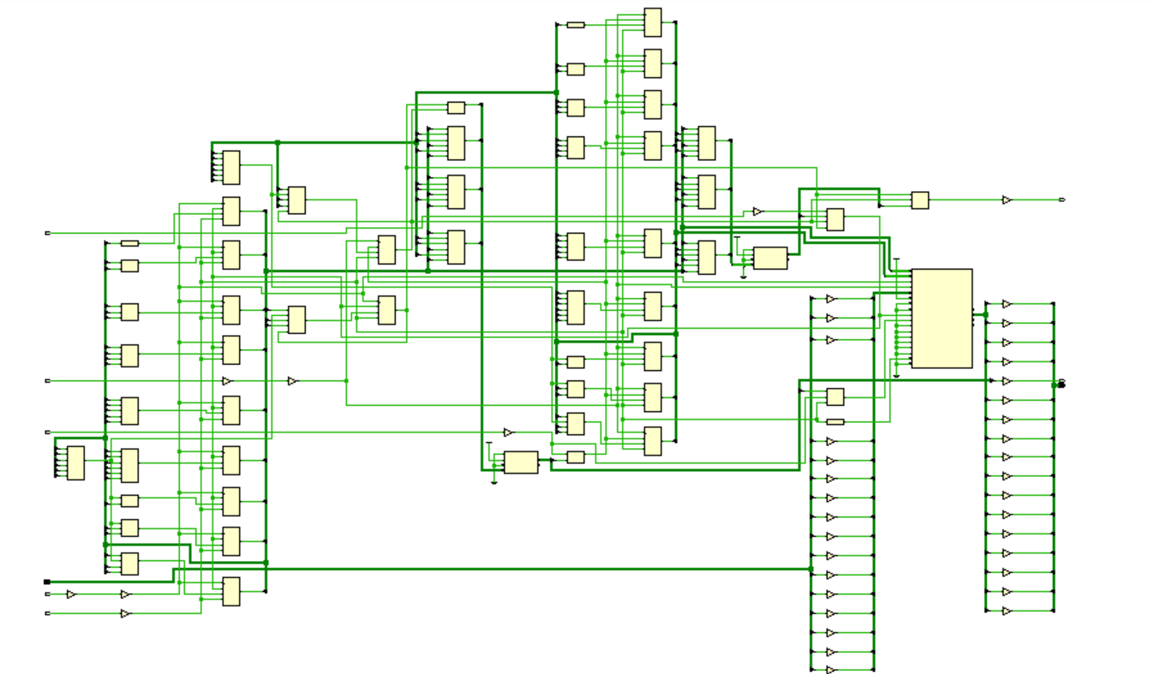

## 8.Netlist

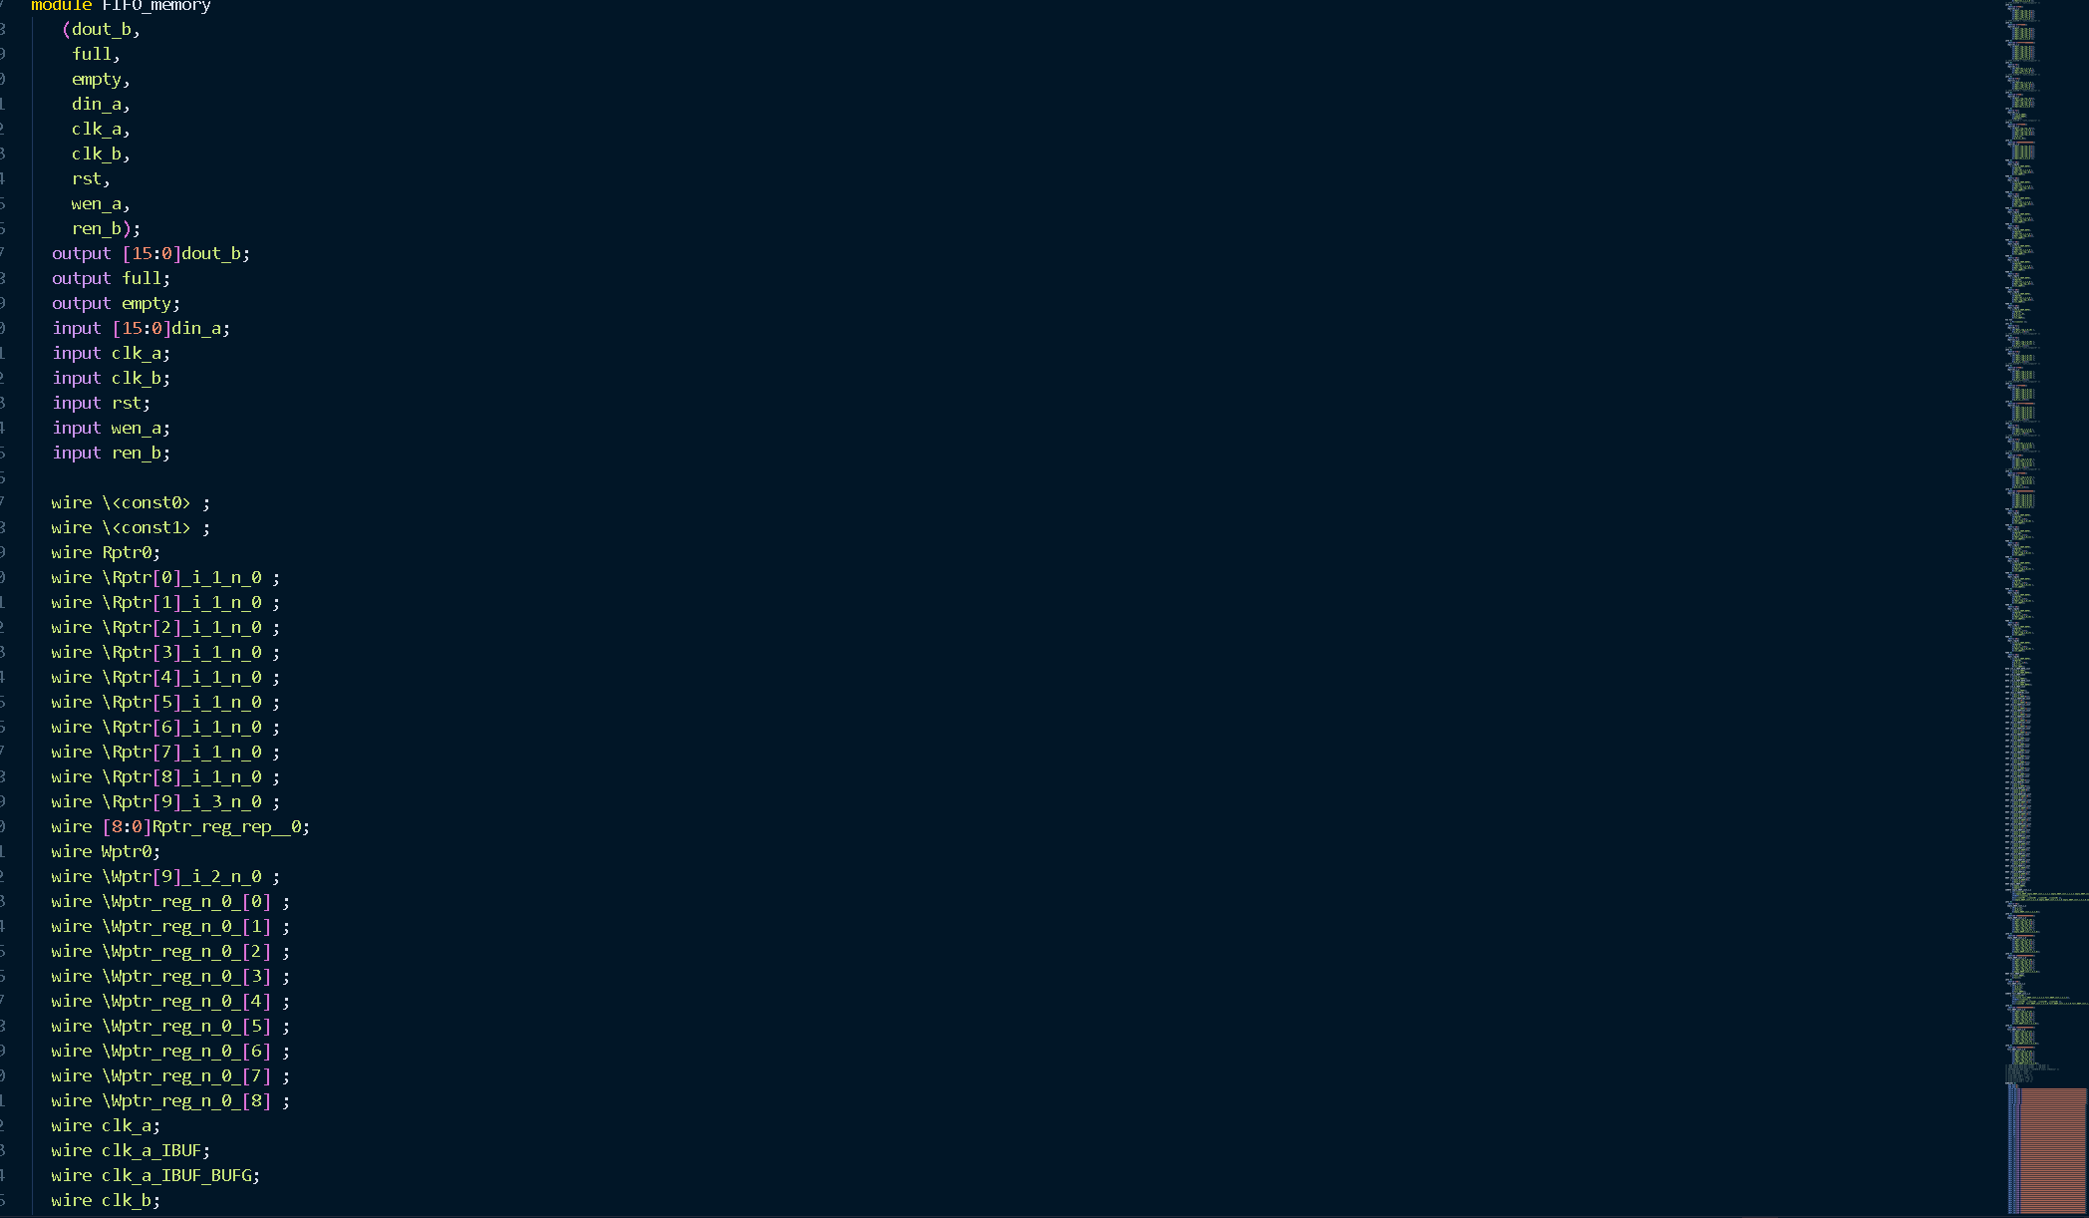

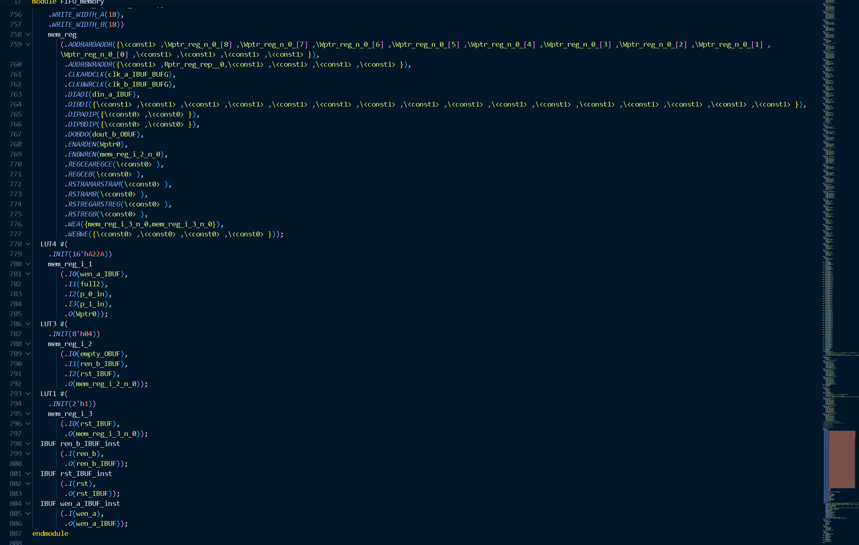

# **9. Linting**

Lint snippet

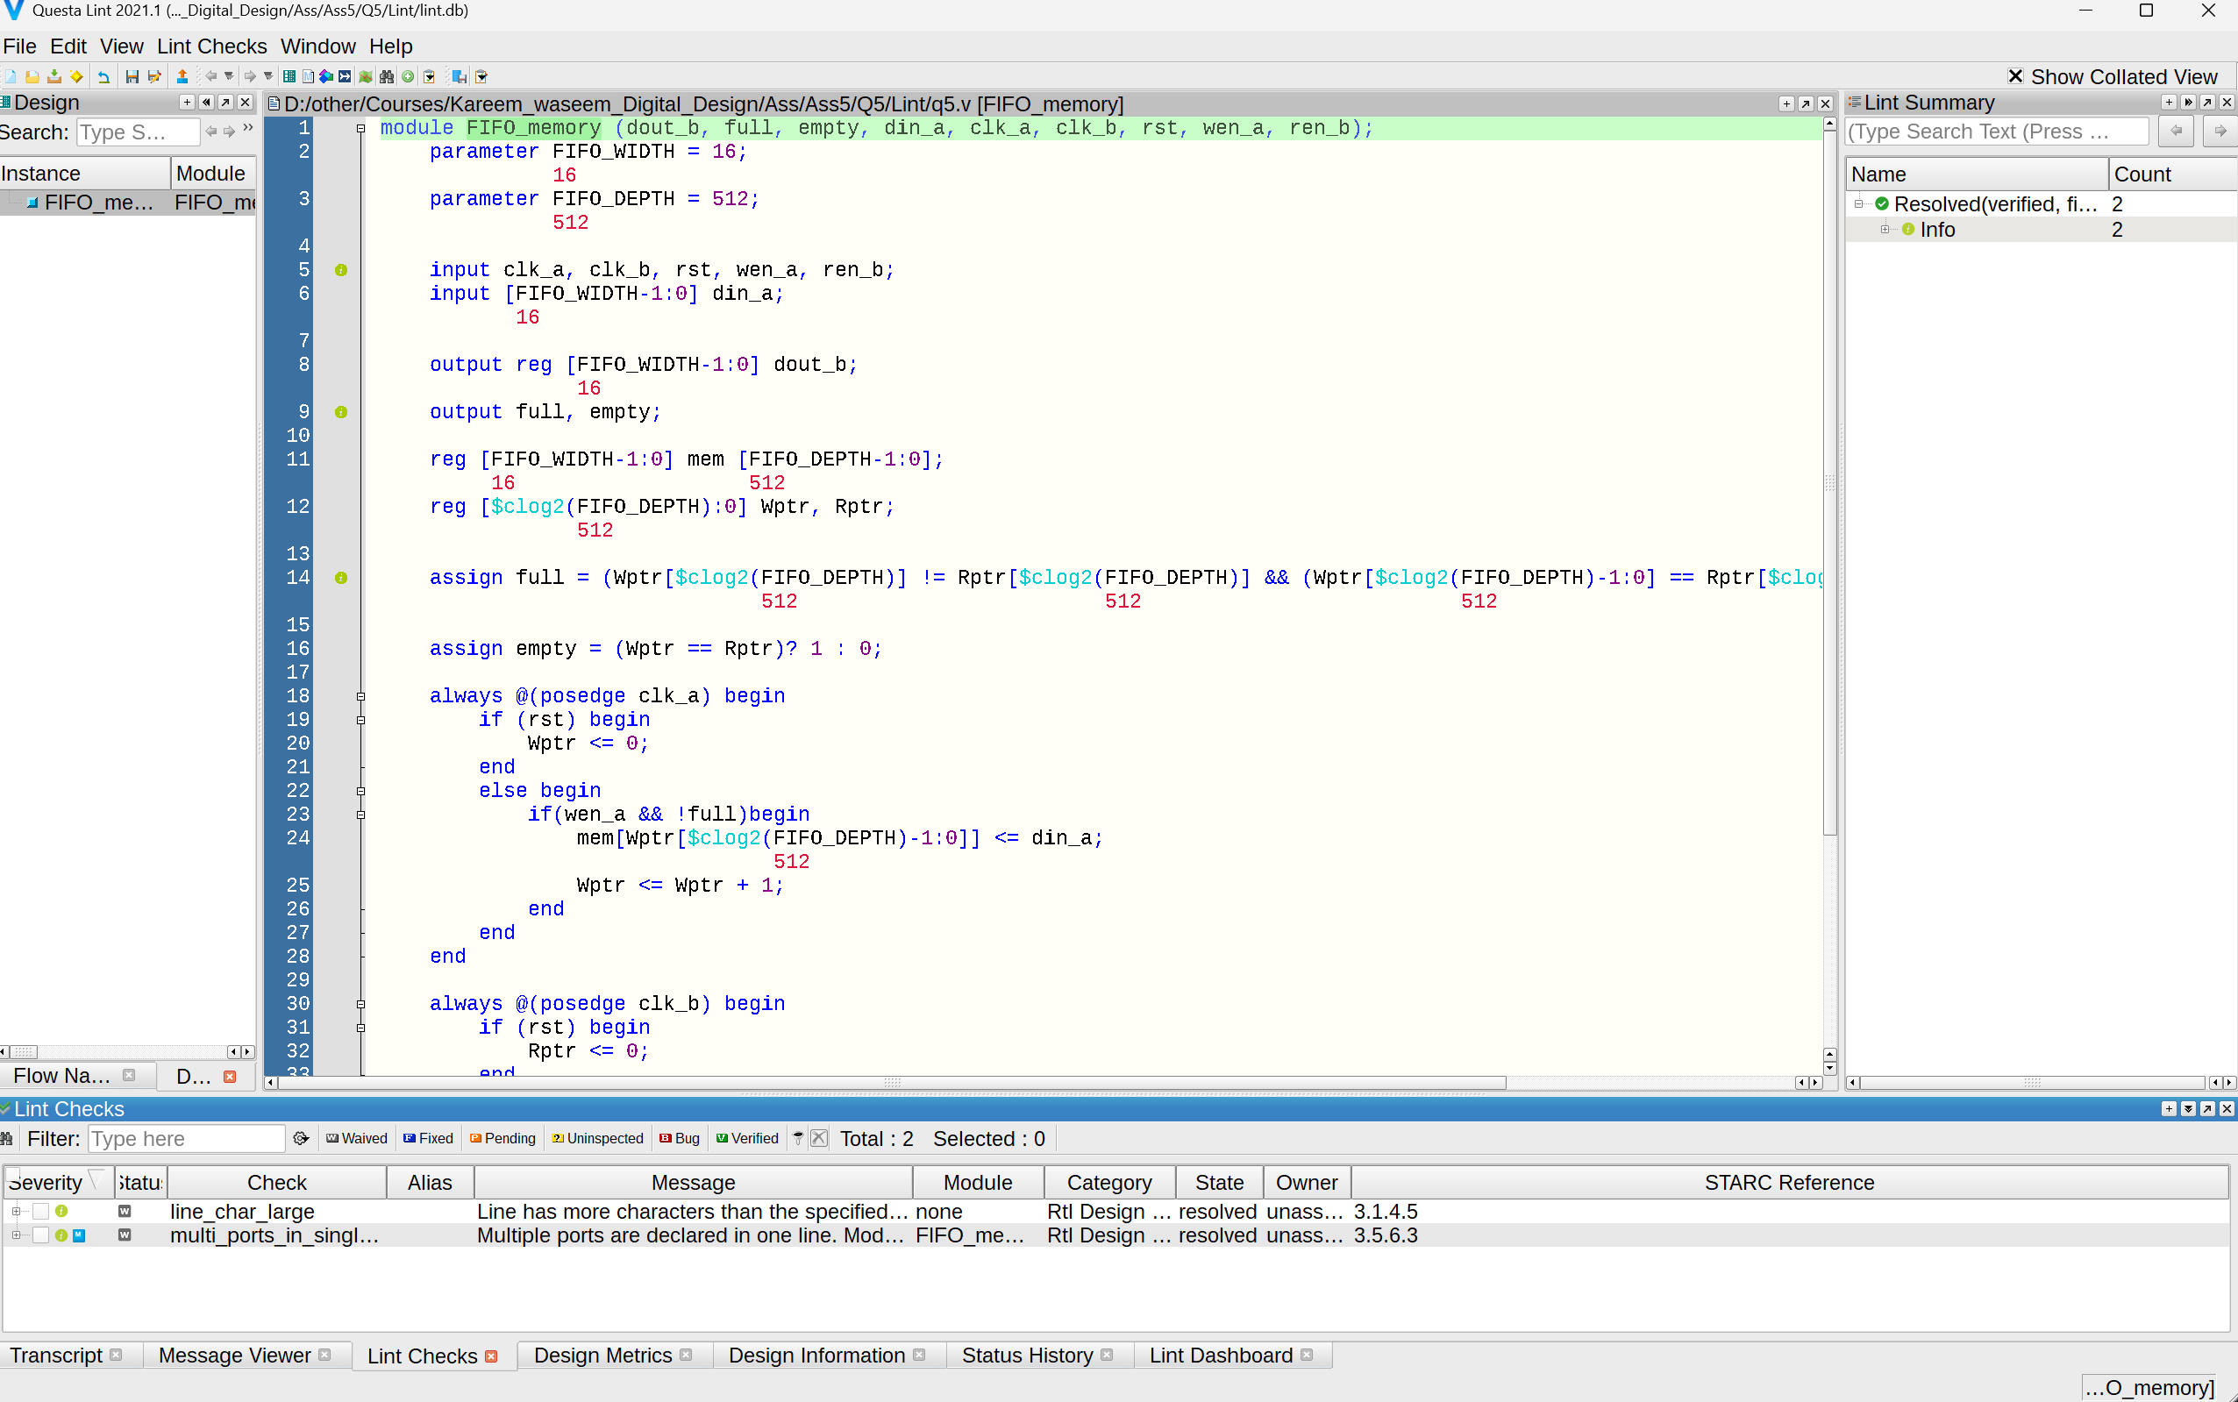

Lint Schematic

